### **A CRM Application to Manage the Booking of Co-Living**

**By**

**SHREYAS RAMA**

**Email id - [21051339@kiit.ac.in](mailto:21051339@kiit.ac.in)**

**Personal Email id - [shreyasrama03@gmail.com](mailto:shreyasrama03@gmail.com)**

**Project Abstract**

This project involves the development of a CRM application designed to streamline and manage the booking process for co-living. The application integrates with various modules within Salesforce to provide a seamless experience for both users and administrators. Key functionalities include real-time availability tracking, automated booking workflows, personalized communication, and detailed analytics for occupancy and revenue management. The system is tailored to enhance customer experience, reduce administrative overhead, and provide actionable insights for property managers. Through this project, the potential of Salesforce as a comprehensive platform for managing co-living spaces has been fully leveraged, demonstrating its capacity to support the growing trend of communal living environments.

**INDEX Page**

**Topics Page no**

Topic no 1 - Introduction and Task 1 01 - 03

Topic no 2 - Task 2 04 - 10

Topic no 3 - Task 3 10 - 15

Topic no 4 - Task 4 15 - 18

Topic no 5 - Task 5 18 - 38

Topic no 6 - Task 6 39 - 41

Topic no 7 - Task 7 41 - 44

Topic no 8 - Task 8 44 - 46

Topic no 9 - Task 9 47 - 50

Topic no 10 - Task 10 50 - 52

Topic no 11 - Task 11 53 - 54

Topic no 12 - Task 12 54 - 56

Topic no 13 - Task 13 57 - 63

**INTRODUCTION**

In the evolving landscape of urban living, co-living spaces have emerged as a popular solution for individuals seeking affordable, community-oriented housing options. As the demand for co-living increases, the need for efficient management systems has become more critical. This project focuses on the development of a Customer Relationship Management (CRM) application using Salesforce, aimed at optimizing the booking and management of co-living spaces.

The CRM application is designed to address the unique challenges associated with managing co-living environments, including the coordination of multiple bookings, maintaining occupancy rates, and ensuring a seamless experience for residents. By leveraging the powerful capabilities of Salesforce, this application integrates various functionalities such as real-time availability tracking, automated booking workflows, and personalized communication channels.

The implementation of this CRM system not only enhances operational efficiency but also significantly improves the overall customer experience, making it easier for both property managers and residents to navigate the complexities of co-living arrangements. Through this project, the potential of Salesforce as a versatile platform for managing modern housing solutions is effectively demonstrated, paving the way for future innovations in the real estate industry.

**Task 1:**

Creating a developer org in salesforce.   
1. Go to <https://developer.salesforce.com/signup>  
2. On the sign up form, enter the following details :

[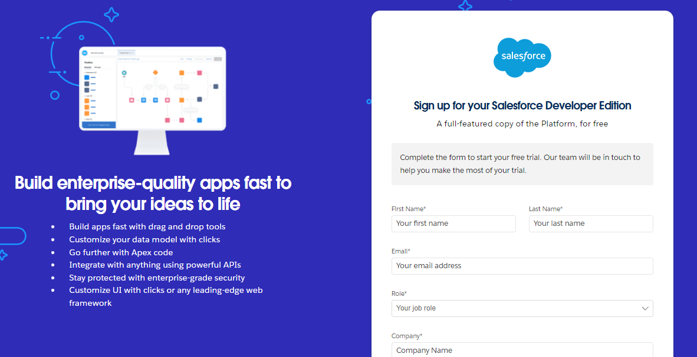](https://developers.salesforce.com/Signup*)

1. First name & Last name
2. Email
3. Role : Developer
4. Company : College Name
5. County : India
6. Postal Code : pin code

Username : should be a combination of your name and company  
This need not be an actual email id, you can give anything in the format : username@organization.com   
Click on sign me up after filling these.

### **Account Activation**

1. Go to the inbox of the email that you used while signing up. Click on the verify account to activate your account. The email may take 5-10mins.

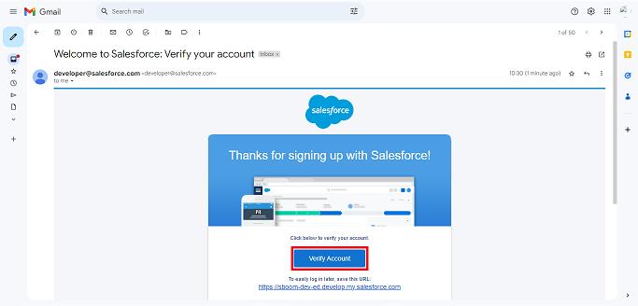  
2. Click on Verify Account  
3. Give a password and answer a security question and click on change password.

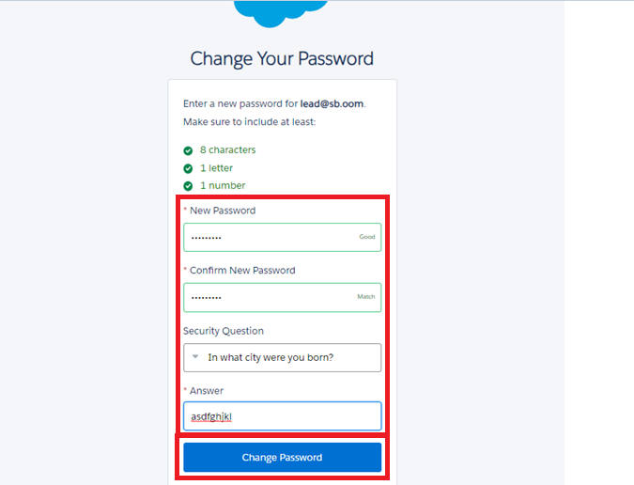  
4. when you will redirect to your salesforce setup page.

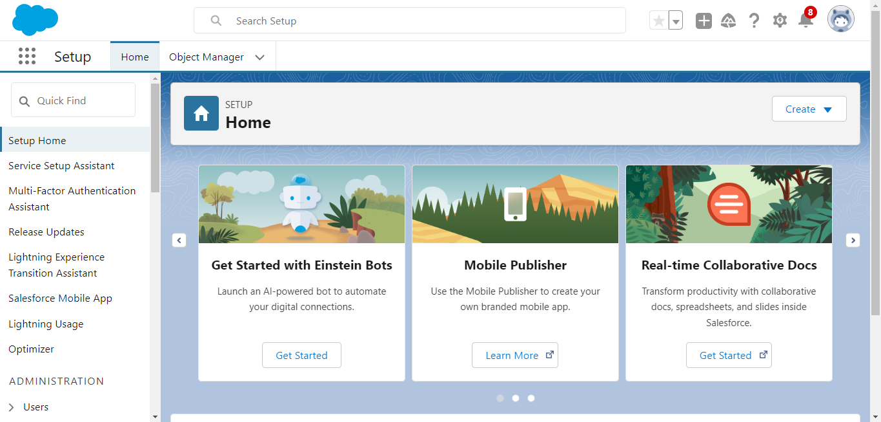

**Screenshot:**

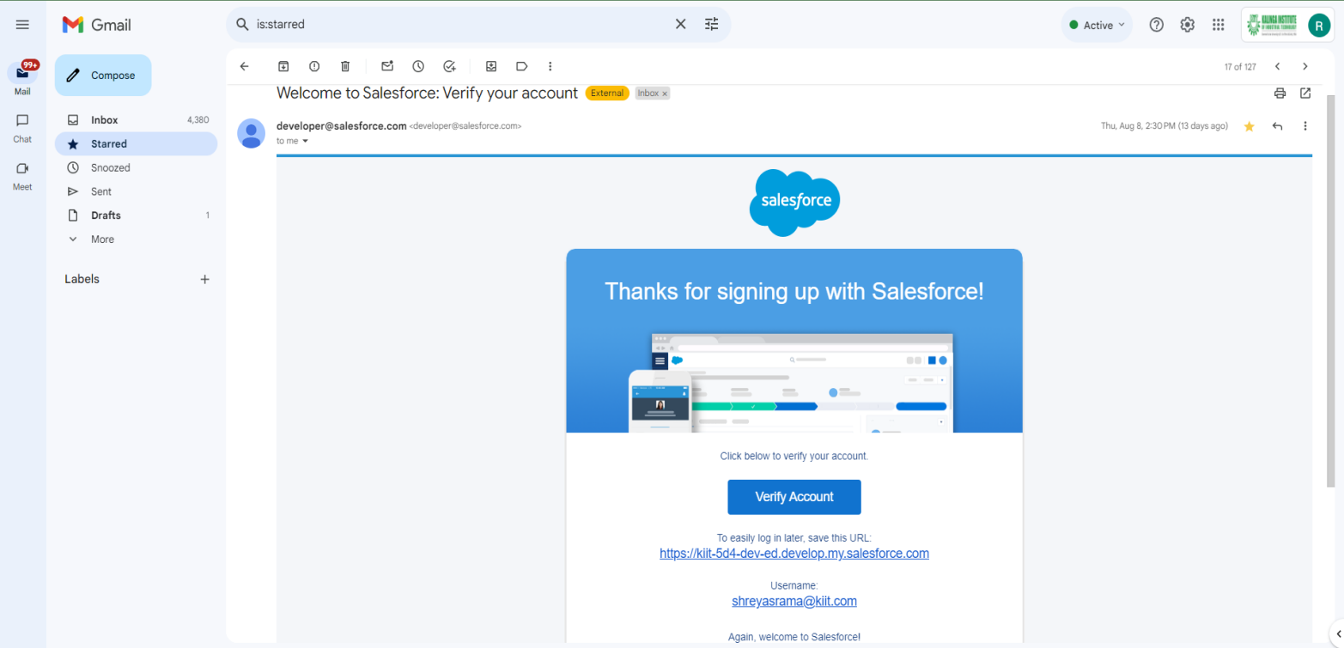

**Task 2:**

### **Create a custom object for Total Rooms**

Create a custom object for Total Rooms:  
To create a custom object, follow these steps:  
1. From setup click on object manager.  
2. Click create, select custom object.

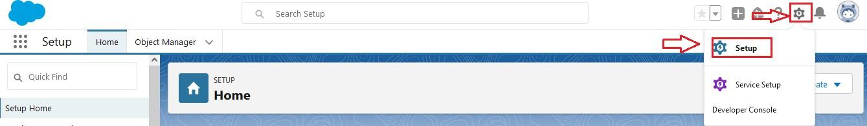

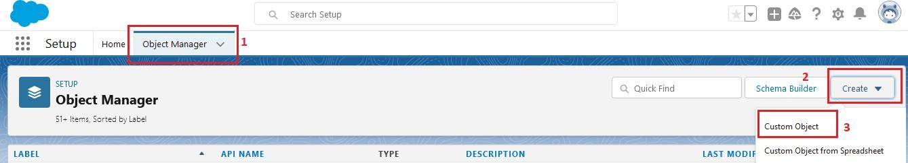  
3. Fill in the label as " Total Room ".  
4. Fill in the plural label as " Total Rooms ".  
5. Record name: "Total No Of Rooms"  
6. Select the data type as "Text".  
7. In the Optional Features section, select Allow Reports and Track Field History.  
8. In the Deployment Status section, ensure Deployed is selected.  
9. In the Search Status section, select Allow Search.  
10. In the Object Creation Options section, select Add Notes and Attachments related list to default page layout.

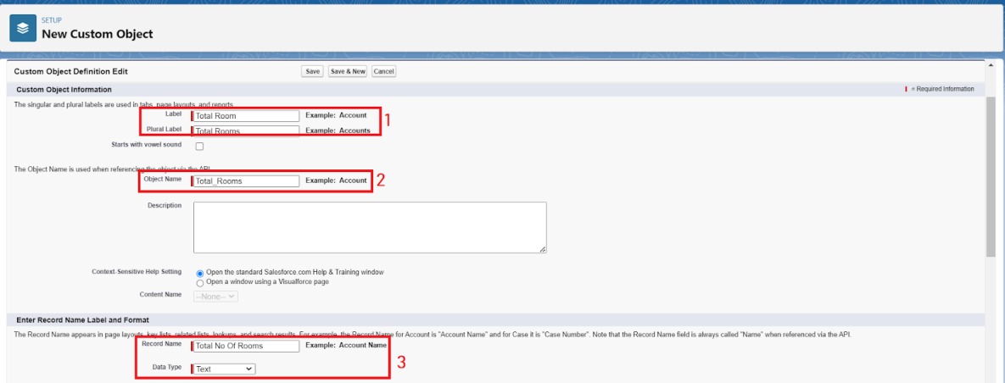  
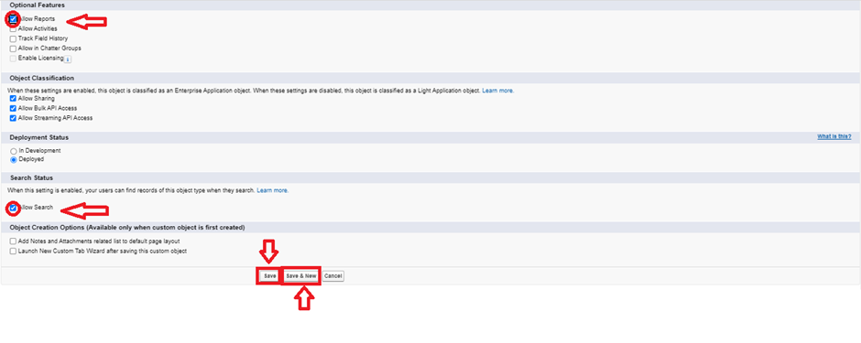  
11. Leave everything else as is, and click Save.

**Screenshot:**

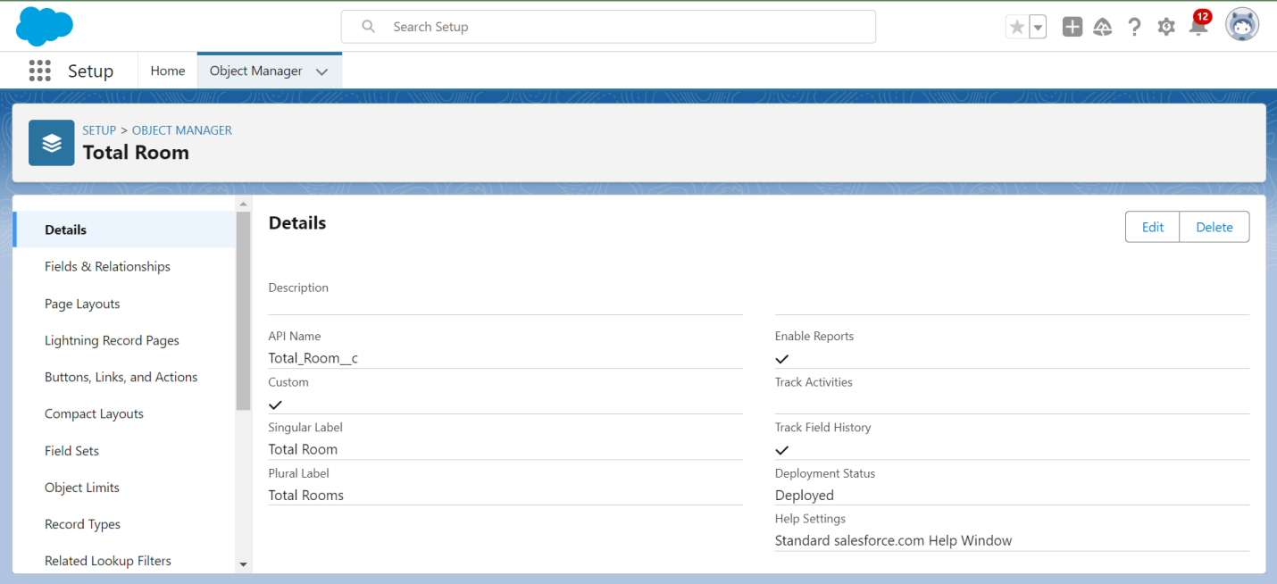

### **Create a custom object for Customer**

To create a custom object, follow these steps:

1. From setup click on object manager.
2. Click create, select custom object.
3. Fill in the label as " Customer1 ".
4. Fill in the plural label as " Customers ".
5. Record name: "Customer Name"
6. Select the data type as "Text".
7. In the Optional Features section, select Allow Reports and Track Field History.
8. In the Deployment Status section, ensure Deployed is selected.
9. In the Search Status section, select Allow Search.
10. In the Object Creation Options section, select Add Notes and Attachments related list to default page layout.
11. Leave everything else as is, and click Save.

**Screenshot:**

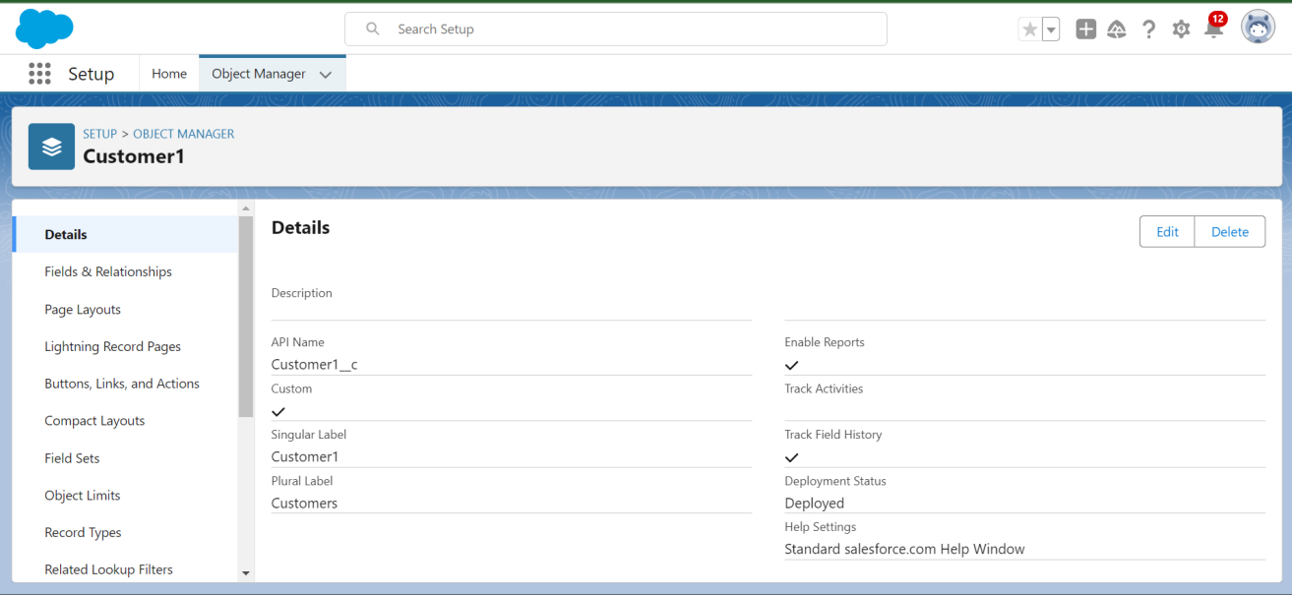

### **Create a custom object for Room Booking**

To create a custom object, follow these steps:

1. From setup click on object manager.
2. Click create, select custom object.
3. Fill in the label as " Room Booking ".
4. Fill in the plural label as " Room Bookings ".
5. Record name: "Room No "
6. Select the data type as "Auto number ".
7. Under Display format enter RN-{000}
8. Enter starting Number as 1
9. In the Optional Features section, select Allow Reports and Track Field History.
10. In the Deployment Status section, ensure Deployed is selected.
11. In the Search Status section, select Allow Search.
12. In the Object Creation Options section, select Add Notes and Attachments related list to default page layout.
13. Leave everything else as is, and click Save.

**Screenshot:**

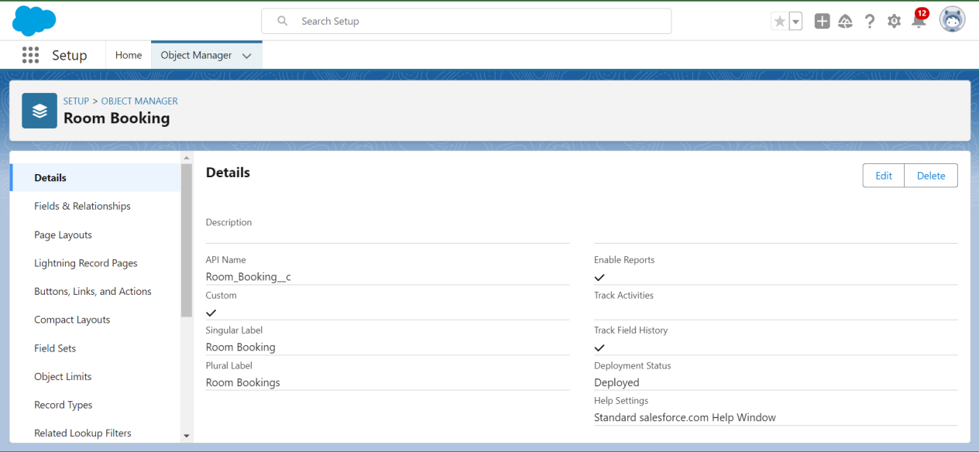

### **Create a custom object for Payment**

To create a custom object, follow these steps:

* From setup click on object manager.
* Click create, select custom object.
* Fill in the label as " Payment1".
* Fill in the plural label as " Payments ".
* Record name: "Payment No "
* Select the data type as "Auto number ".
* Under Display format enter PNO-{000}
* Enter starting Number as 1
* In the Optional Features section, select Allow Reports and Track Field History.
* In the Deployment Status section, ensure Deployed is selected.
* In the Search Status section, select Allow Search.
* In the Object Creation Options section, select Add Notes and Attachments related list to default page layout.
* Leave everything else as is, and click Save.

**Screenshot:**

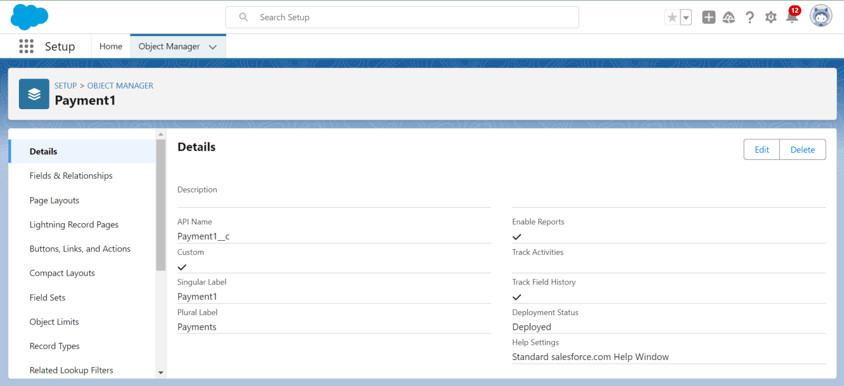

### **Create a custom object for Food Selection**

To create a custom object, follow these steps:

1. From setup click on object manager.
2. Click create, select custom object.
3. Fill in the label as " Food Selection ".
4. Fill in the plural label as " Food Selections ".
5. Record name: " Food Selection No "
6. Select the data type as "Auto number ".
7. Under Display format enter FS No-{000}
8. Enter starting Number as 1
9. In the Optional Features section, select Allow Reports and Track Field History.
10. In the Deployment Status section, ensure Deployed is selected.
11. In the Search Status section, select Allow Search.
12. In the Object Creation Options section, select Add Notes and Attachments related list to default page layout.

13.Leave everything else as is, and click Save.

**Screenshot:**

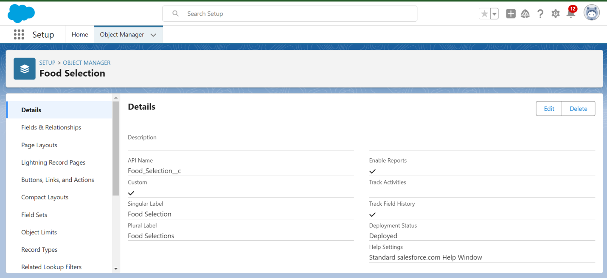

### **Create a custom object for Feedback**

To create a custom object, follow these steps:

* From setup click on object manager.
* Click create, select custom object.
* Fill in the label as " Feedback ".
* Fill in the plural label as " Feedbacks ".
* Record name: "Feedback No "
* Select the data type as "Auto number ".
* Under Display format enter Fd No-{0000}
* Enter starting Number as 1
* In the Optional Features section, select Allow Reports and Track Field History.
* In the Deployment Status section, ensure Deployed is selected.
* In the Search Status section, select Allow Search.
* In the Object Creation Options section, select Add Notes and Attachments related list to default page layout.
* Leave everything else as is, and click Save.

**Screenshot:**

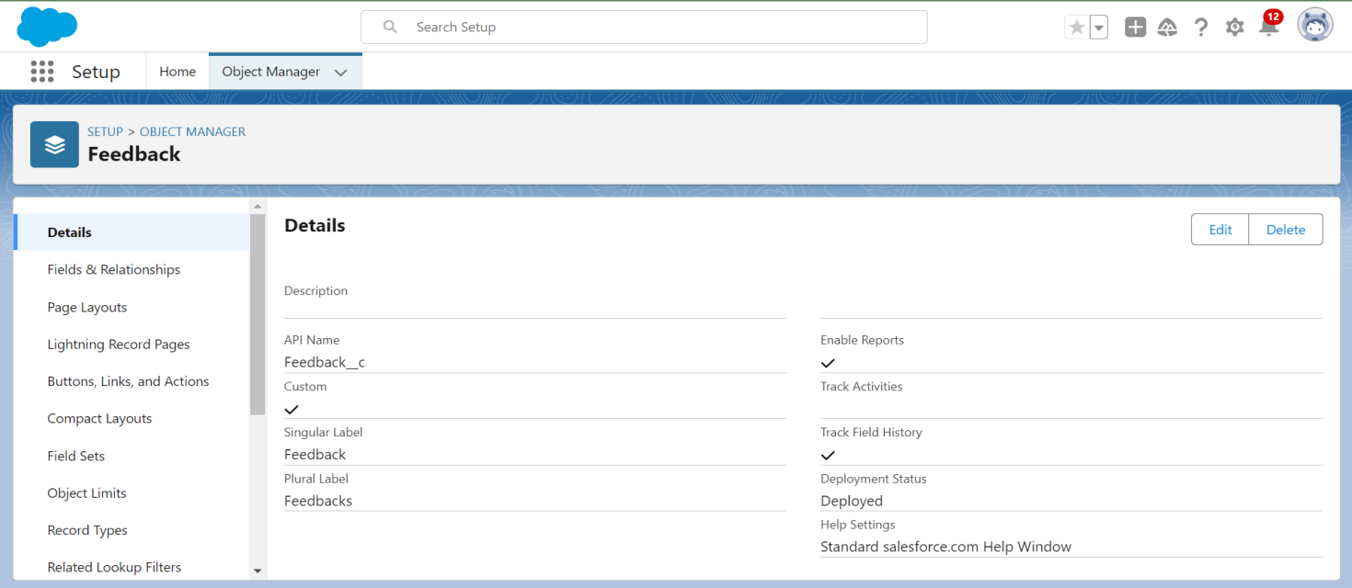

**Task 3:**

### **Creating a Tab for Total Rooms**

**To create a Tab:(Total Rooms)**1. Go to setup page > type Tabs in Quick Find bar > click on tabs > New (under custom object tab)

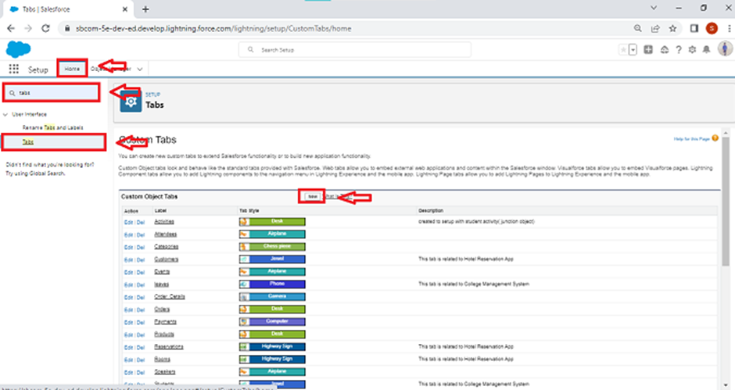

2. Select Object(Total Rooms) > Select the tab style.

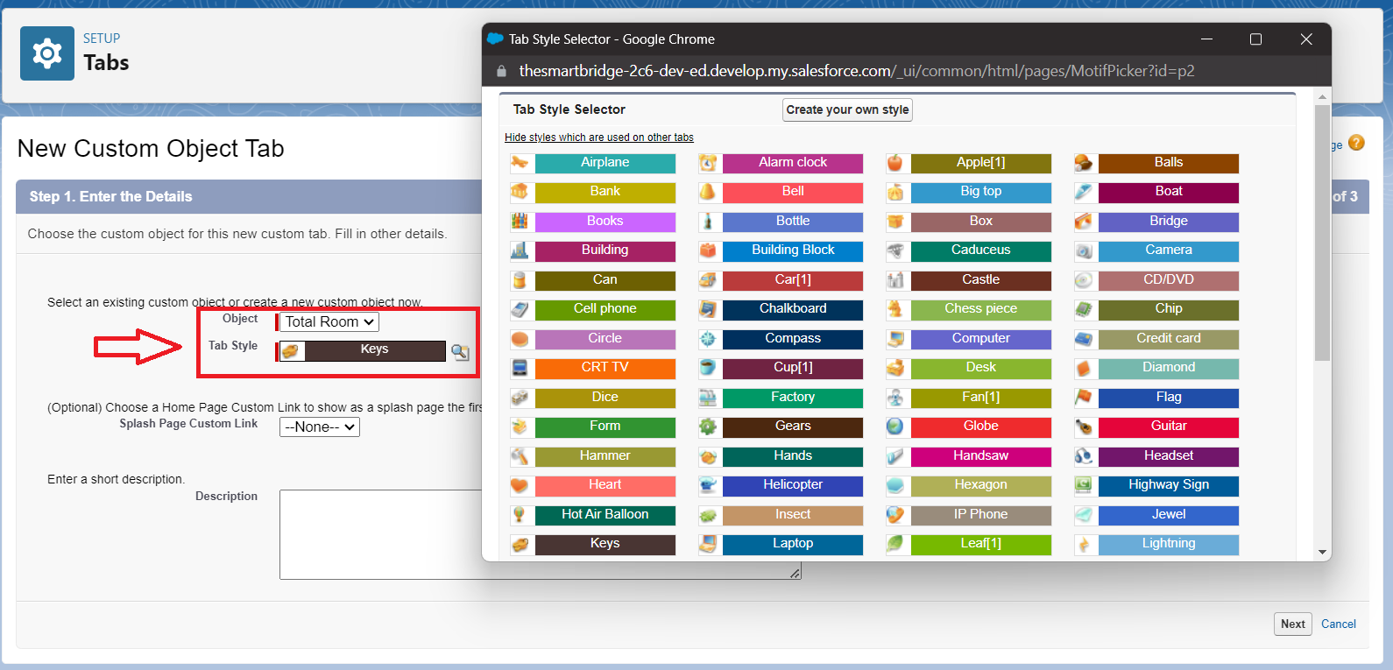

3. Next (Add to profiles page) keep it as default

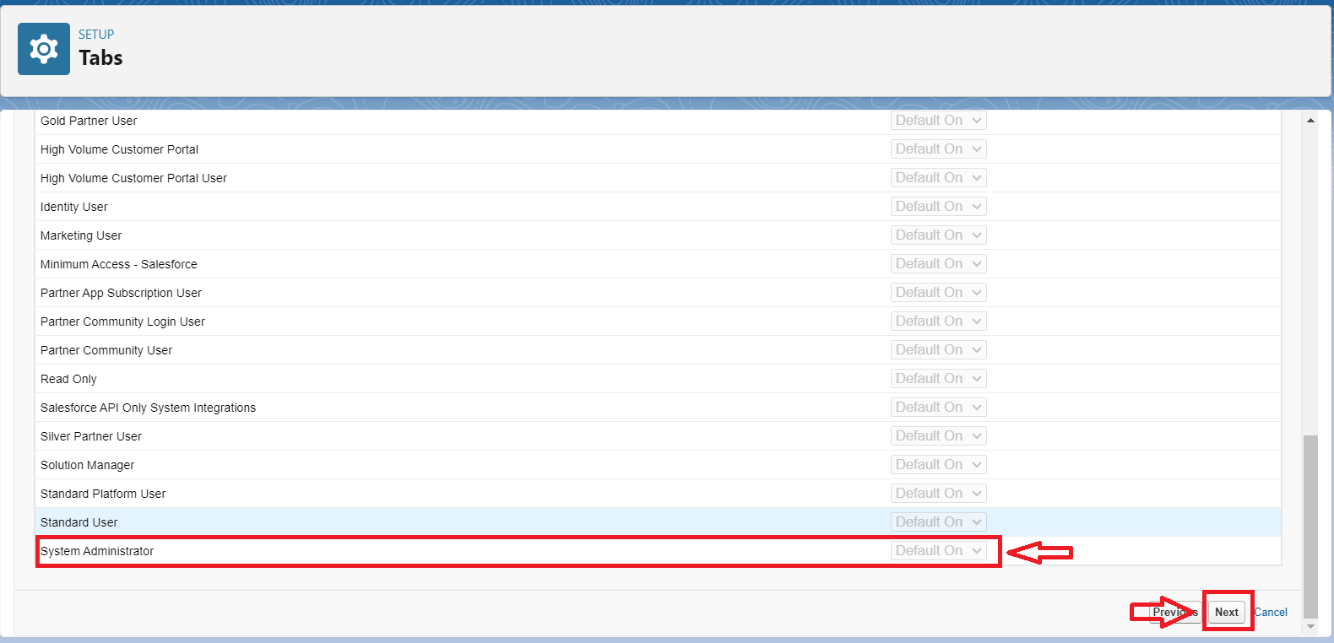

4. Next (Add to Custom App) keep it as default & Save.

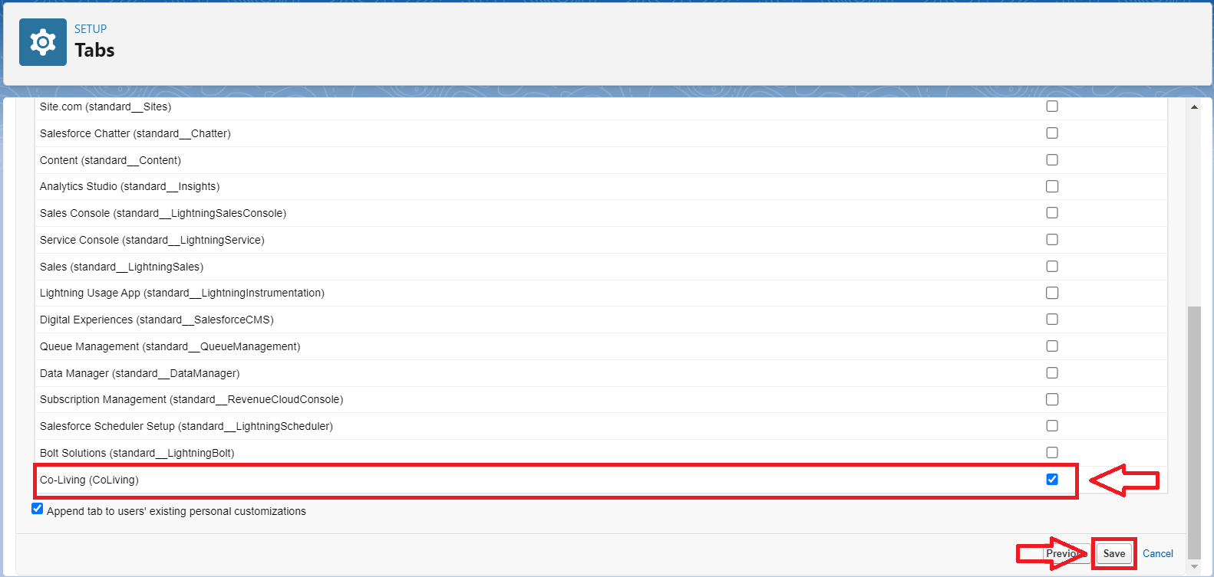

**Screenshot:**

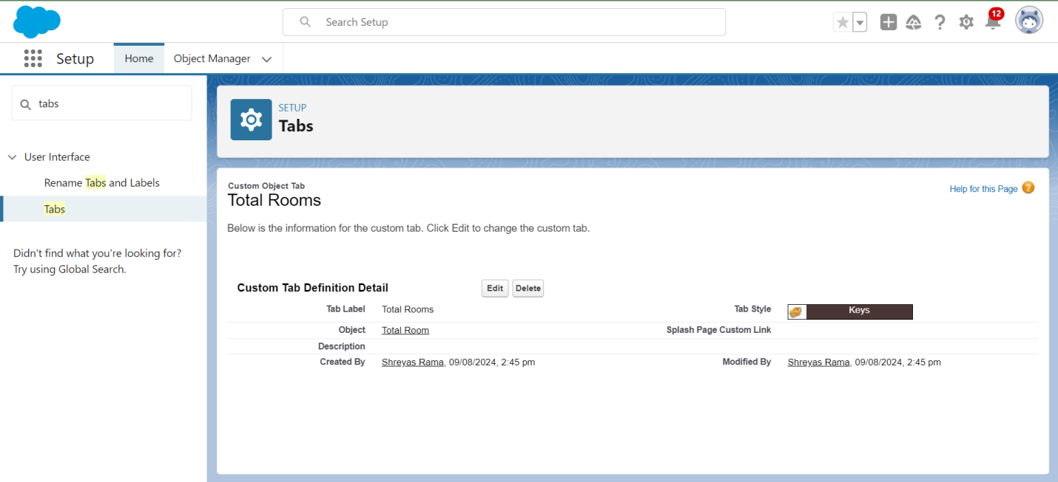

### **Create a Tab for Customers**

To create a Tab:(Customers)

1. Go to setup page > type Tabs in Quick Find bar > click on tabs > New (under custom object tab)
2. Select Object(Customers) > Select the tab style > Next (Add to profiles page) keep it as default > Next (Add to Custom App) keep it as default > Save.

**Screenshot:**

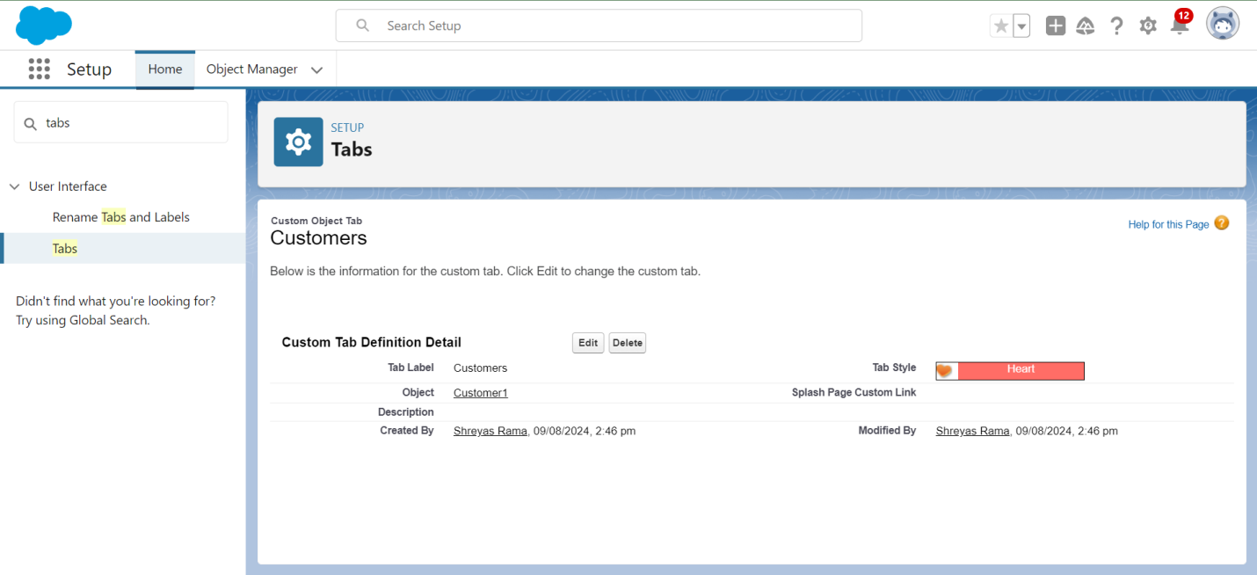

### **To create a Tab for Room Bookings**

To create a Tab:(Room Bookings)

* Go to setup page ? type Tabs in Quick Find bar ? click on tabs ? New (under custom object tab)
* Select Object(Room Bookings) ? Select the tab style ? Next (Add to profiles page) keep it as default ? Next (Add to Custom App) keep it as default ? Save.

**Screenshot:**

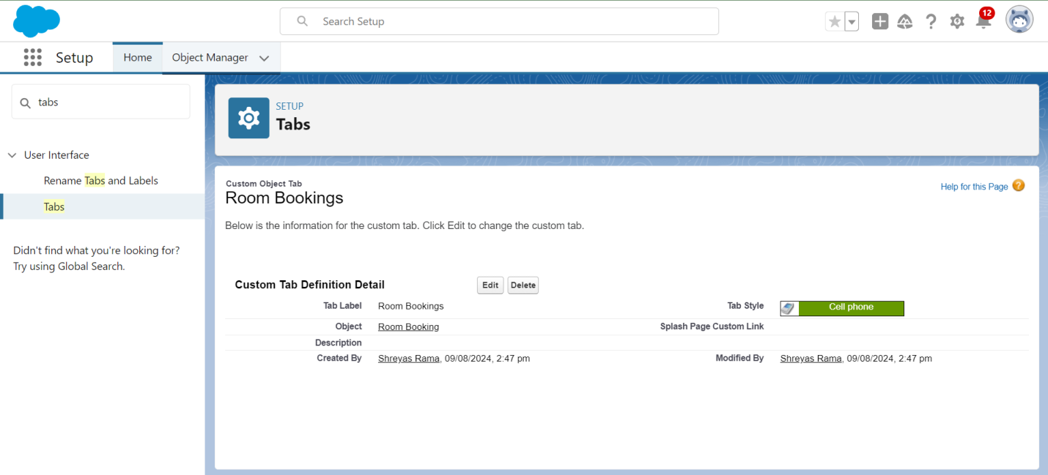

### **Create a Tabs For Remaining Objects**

Now create the tabs for Payments, Food Selections, Feedbacks Objects.

**Screenshot:**

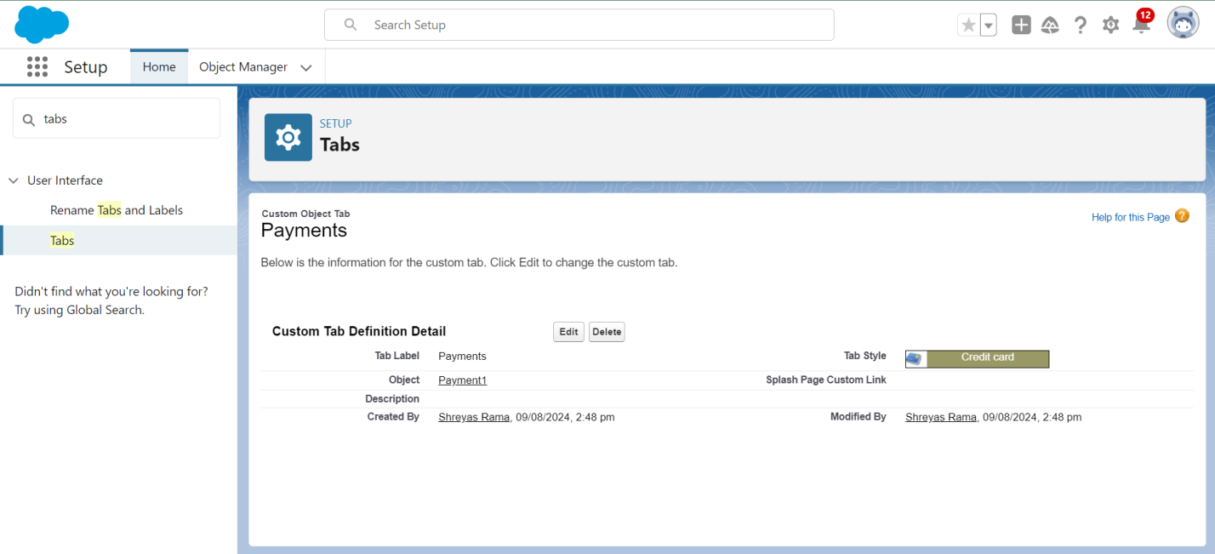

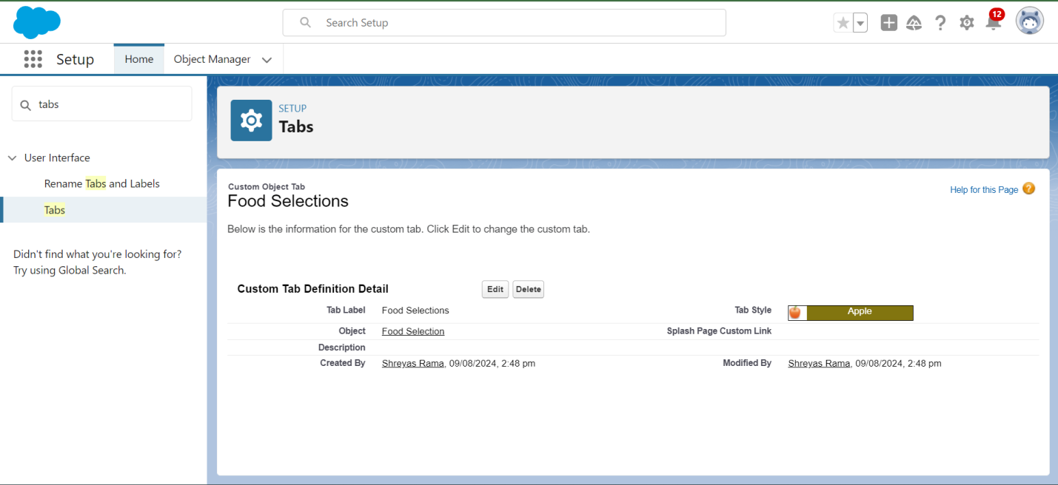

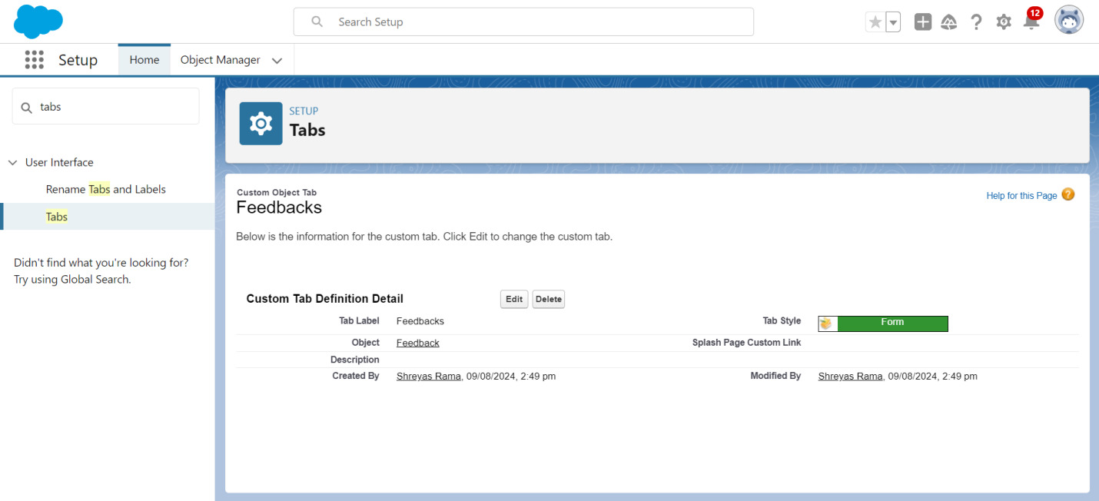

**Task 4:**

### **Create a Lightning App**

**To create a lightning app page:**1. Go to setup page > search “app manager” in quick find > select “app manager” > click on New lightning App.

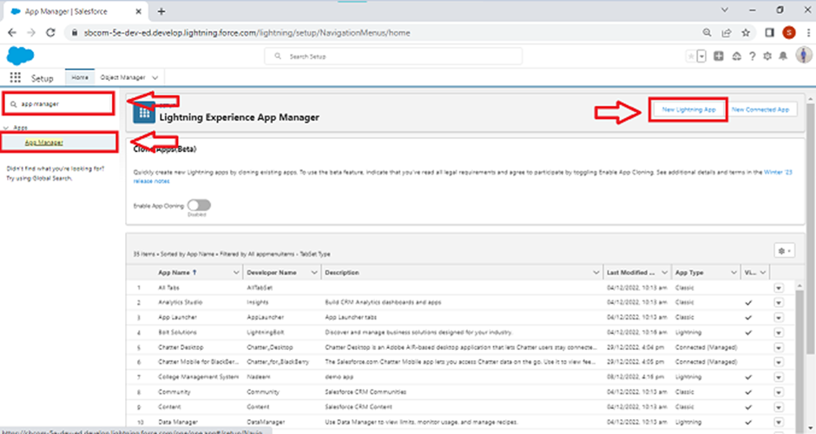  
2. Fill the app name in app details and branding > Next  > (App option page) keep it as default > Next > (Utility Items) keep it as default > Next.

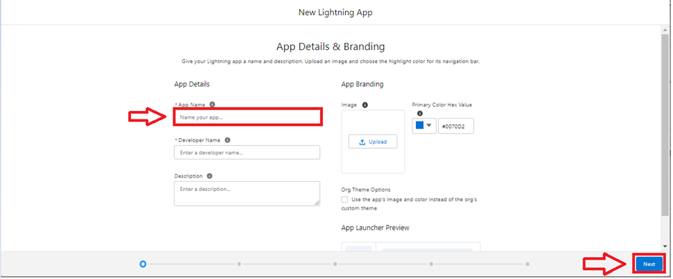  
3. To Add Navigation Items: Ctrl and Select the items (Total Rooms, Customers1, Room Booking, Payments1, Food selection, Feedbacks, Reports and Dashboards) from the search bar and move it using the arrow button > Next.

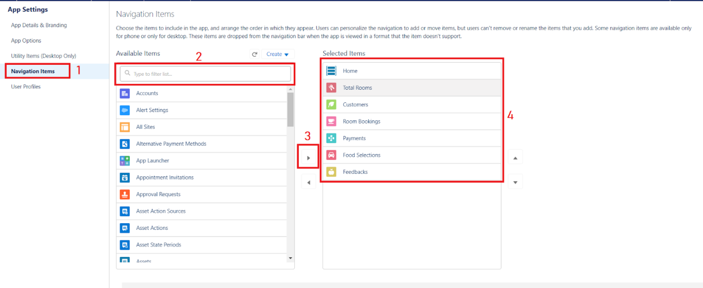  
4. To Add User Profiles:

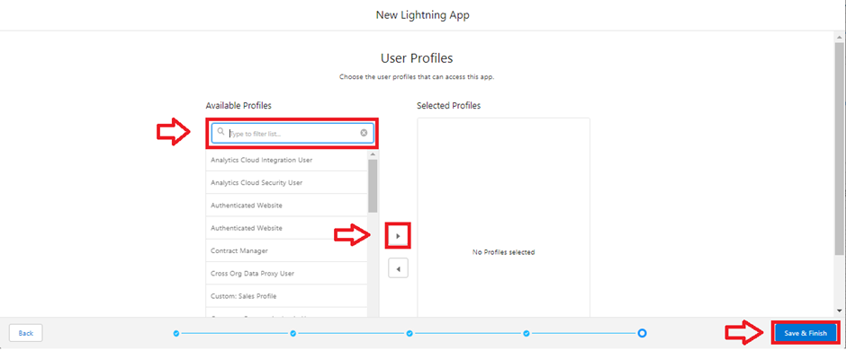  
5. Search profiles (System administrator) in the search bar > click on the arrow button > save & finish.

**Screenshot:**

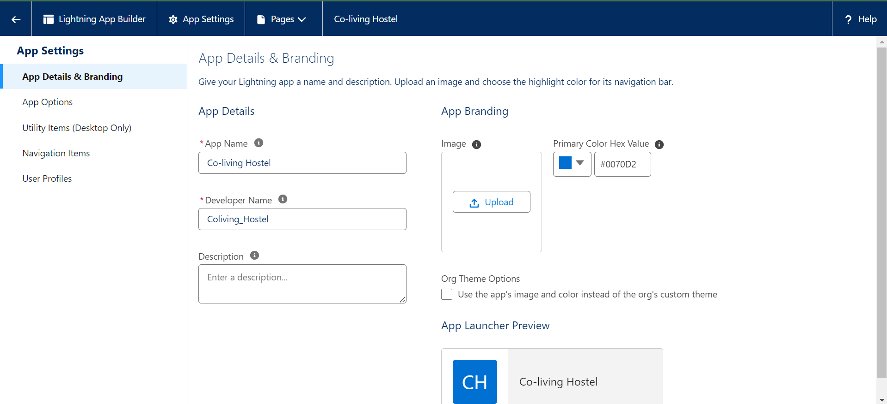

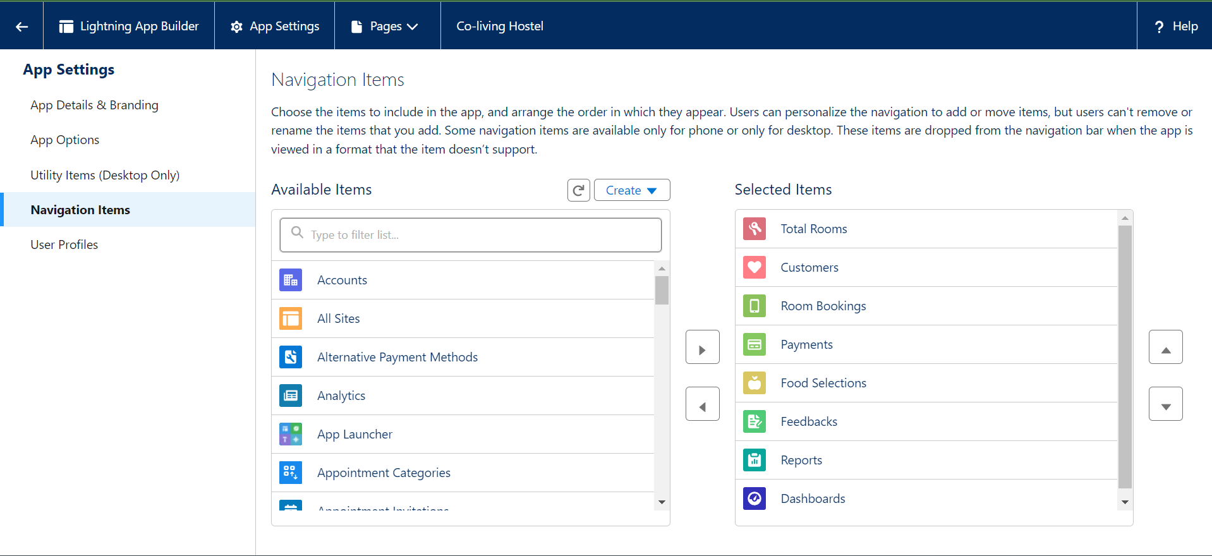

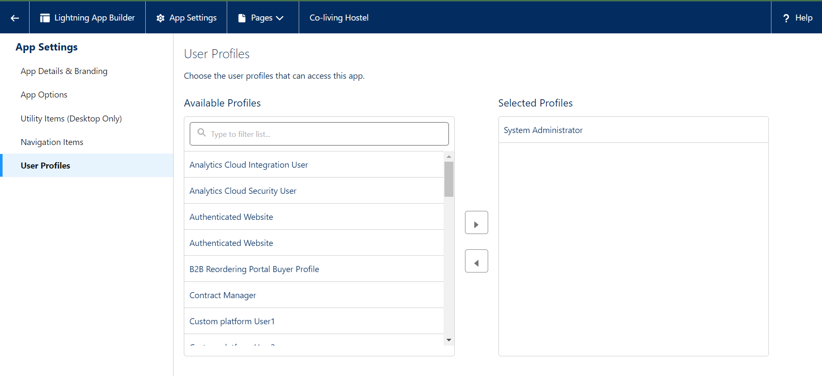

**Task 5:**

### **Creation of fields for the customer1 object**

**To create fields in an object:** Go to setup > click on Object Manager > type object name(Customer1) in search bar > click on the object.

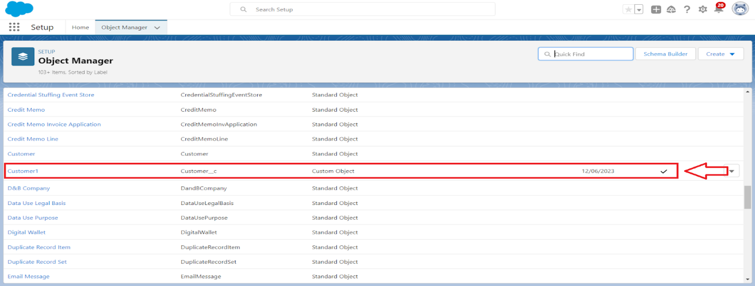  
Now click on “Fields & Relationships” > New

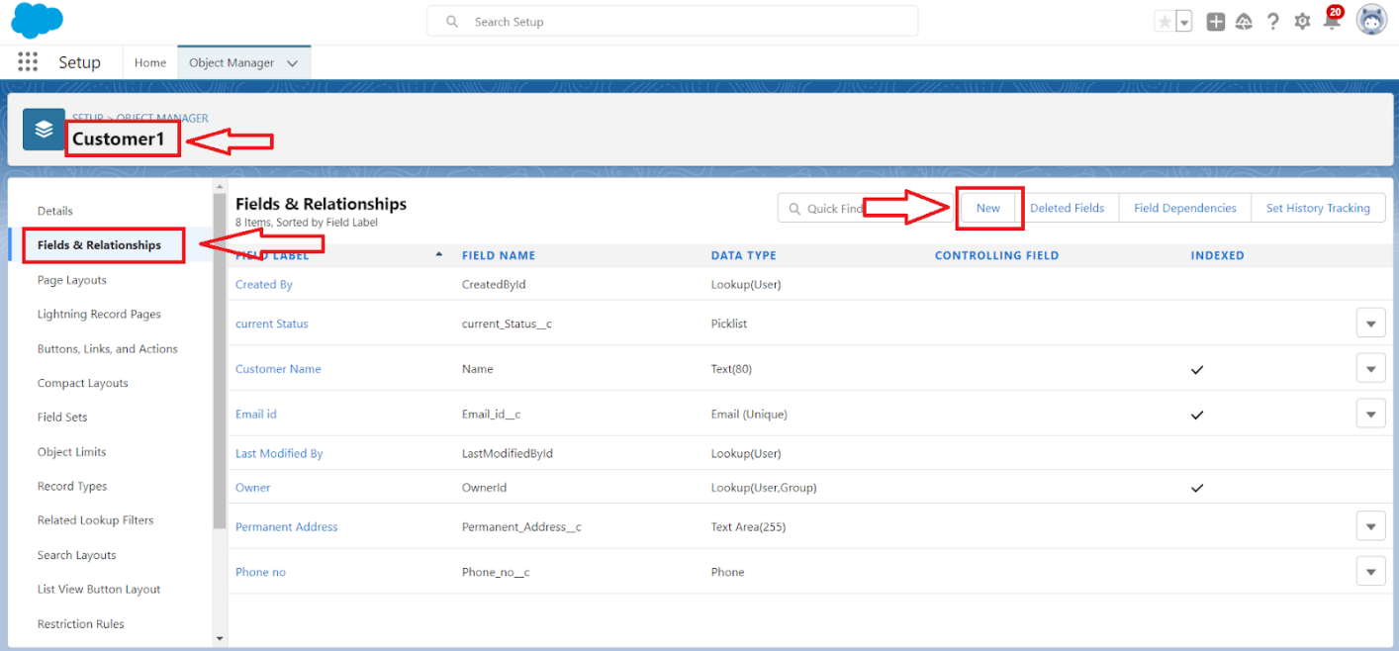  
Select Data Type as a “Phone”

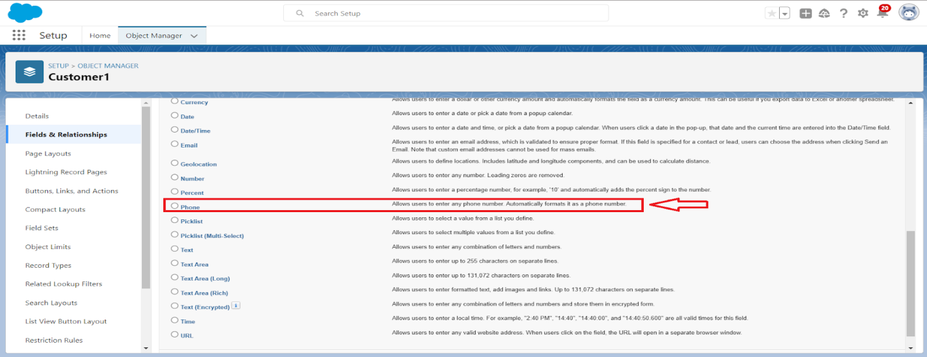  
Click on next

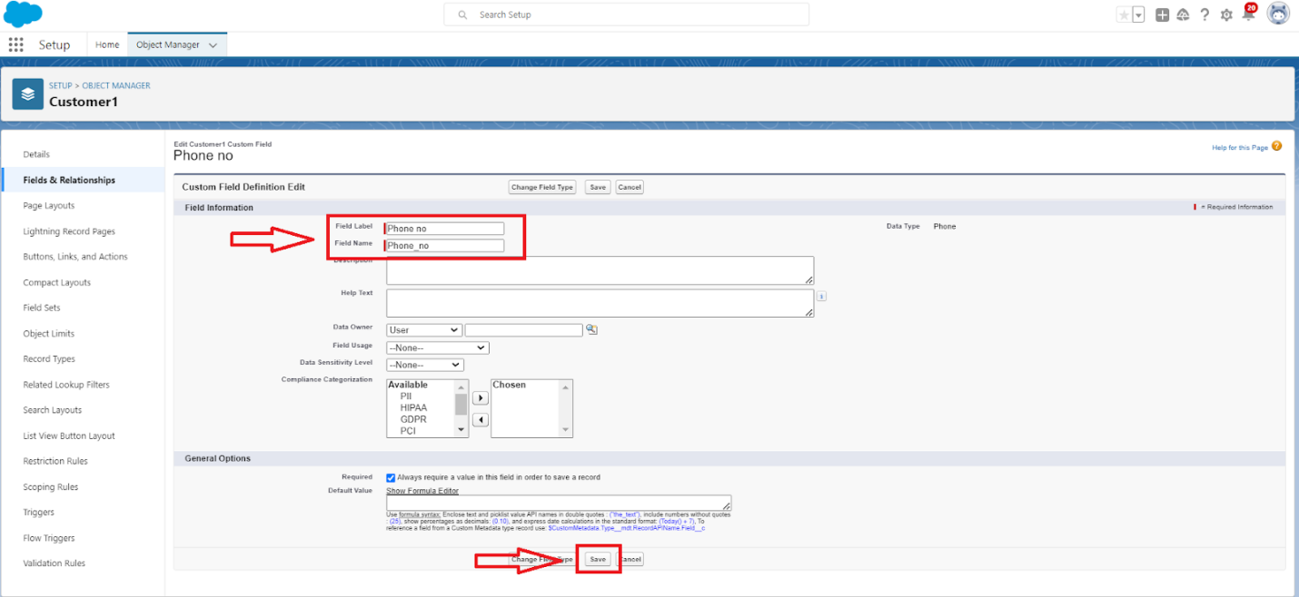  
Fill the Above as following:

Field Label: Phone no

Field Name : gets auto generated

Click on Next > Next > Save and new.

To create another fields in an object:

Go to setup > click on Object Manager > type object name(Customer1) in search bar > click on the object.

Now click on “Fields & Relationships” > New

Select Data type as a “Email” and Click on Next

Fill the Above as following:

Field Label: Email

Field Name :It’s  gets auto generated

Click on Next > Next > Save and new.

To create another fields in an object:

Go to setup > click on Object Manager > type object name(Customer1) in search bar > click on the object.

Now click on “Fields & Relationships” ? New

Select Data type as a “Text Area” and Click on Next

Fill the Above as following:

Field Label: Permanent Address

Field Name : It’s gets auto generated

Click on Next > Next > Save and new.

To create another fields in an object:

Go to setup > click on Object Manager > type object name(Customer1) in search bar > click on the object.

Now click on “Fields & Relationships” > New

Select Data type as a “Picklist” and Click on Next

Fill the Above as following:

Field Label: Current Status

Value - Select enter values with each value separated by a new line

Student

Employee

Others

Select required

Field Name :It’s gets auto generated

Click on Next > Next > Save and new.

**Screenshot:**

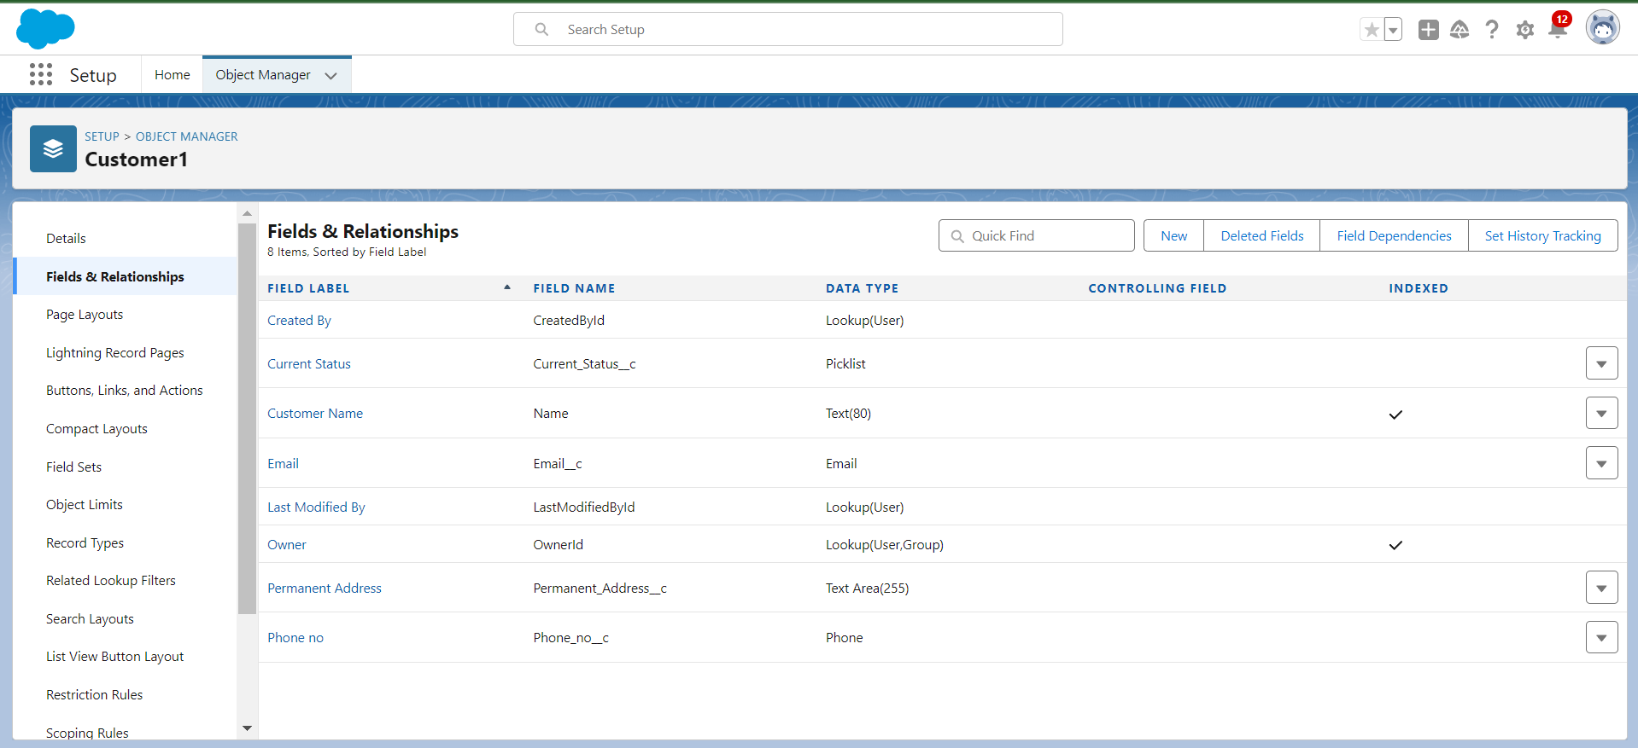

Creation of fields for the Room Booking object

To create fields in an object:

Go to setup > click on Object Manager > type object name(Room Booking) in the search bar > click on the object.

Now click on “Fields & Relationships” > New

Select Data Type as a “Picklist”

Click on Next

Fill the Above as following:

Field Label: Room Sharing

Value - Select enter values with each value separated by a new line

Single sharing

Double sharing

Triple sharing

Select required

Click on Next > Next > Save and new.

To Create a Fields & Relationship to an Room Booking Object

To create fields & relationship to an object:

Go to setup > click on Object Manager > type object name(Room Booking) in the search bar > click on the object.

Now click on “Fields & Relationships” > New

Select Data Type as a “Master-detail Relationship”

Click on Next

Click on the Related to drop down and Select the “Customer1” object and click on Next

Fill the Above as following:

Change the Field Label: Name

Field Name : It’s gets auto generated

Click on Next > Next > Save and new.

To create fields in an object:

Go to setup > click on Object Manager > type object name(Room Booking) in the search bar > click on the object.

Now click on “Fields & Relationships” > New

Select Data Type as a “Checkbox”

Click on Next

Fill the Above as following:

Field Label: AC-3000

Field Name :It’s gets auto generated

Click on Next > Next > Save and new

To create fields in an object:

Go to setup > click on Object Manager > type object name(Room Booking) in the search bar > click on the object.

Now click on “Fields & Relationships” > New

Select Data Type as a “Checkbox”

Click on Next

Fill the Above as following:

Field Label: Advance Payment for 1 Month

Field Name :It’s gets auto generated

Click on Next > Next > Save and new

To create fields in an object:

Go to setup ? click on Object Manager ? type object name(Room Booking) in the search bar ? click on the object.

Now click on “Fields & Relationships” ? New

Select Data Type as a “Currency”

Click on Next

Fill the Above as following:

Field Label: Amount

Length: (18,0)

Field Name :It’s gets auto generated

Click on Next > Next > Save and new

To Create a Fields & Relationship to an Object

Go to setup > click on Object Manager > type object name(Room Booking) in the search bar > click on the object.

Now click on “Fields & Relationships” ? New

Select Data Type as a “Master-detail Relationship”

Click on Next

Click on the Related to drop down and Select the “Total Rooms” object and click on Next

Fill the Above as following:

Change the Field Label: Total No Of Rooms

Field Name :It’s gets auto generated

Click on Next > Next > Save and new.

To Create a Rollup Summary Field in “Total Room Object”

After Creating the Master- Detail Relationship Than Only you can create the Rollup Summary

Go to setup > click on Object Manager > type object name(Total Rooms) in the search bar > click on the object.

Now click on “Fields & Relationships” ? New

Select Data type as a “Roll-up Summary” and Click on Next

Fill the Above as following:

Field Label: Rooms Booked

Field Name :It’s gets auto generated

Click on Next

Select the Room Bookings in the Summarized Object

Select the count Radio button in the select Roll-up Type

Click on Next > Next > Save and new

To create fields in an object:

Go to setup > click on Object Manager > type object name(Rooms Booking) in the search bar > click on the object.

Now click on “Fields & Relationships” > New

Select Data type as a “Formula” and Click on Next

Fill the Above as following:

Field Label: Rooms Available

Field Name : It’s gets auto generated

Select the Formula Return Type as “Number”

Select the Decimal places as “0” and Click on Next

Click on the Advanced Formula and Enter the value in formula box “ 30 - ” and Click on insert field than you will find a pop window under the Room Booking select the Total No Of Rooms in the second Column and select the Room Booked in the third column and click on insert “ 30  -  Total_No_Of_Rooms__r.Rooms_Booked__c ” and Check Syntax

Click on Next > Next > Save and new.

To create fields in an object:

Go to setup > click on Object Manager > type object name(Room Booking) in the search bar > click on the object.

Now click on “Fields & Relationships” > New

Select Data Type as a “Checkbox”

Click on Next

Fill the Above as following:

Field Label: Check in

Field Name :It’s gets auto generated

Click on Next > Next > Save and new

To create fields in an object:

Go to setup > click on Object Manager > type object name(Room Booking) in the search bar > click on the object.

Now click on “Fields & Relationships” ? New

Select Data Type as a “Checkbox”

Click on Next

Fill the Above as following:

Field Label: Check Out

Field Name :It’s gets auto generated

Click on Next > Next > Save and new

**Screenshot:**

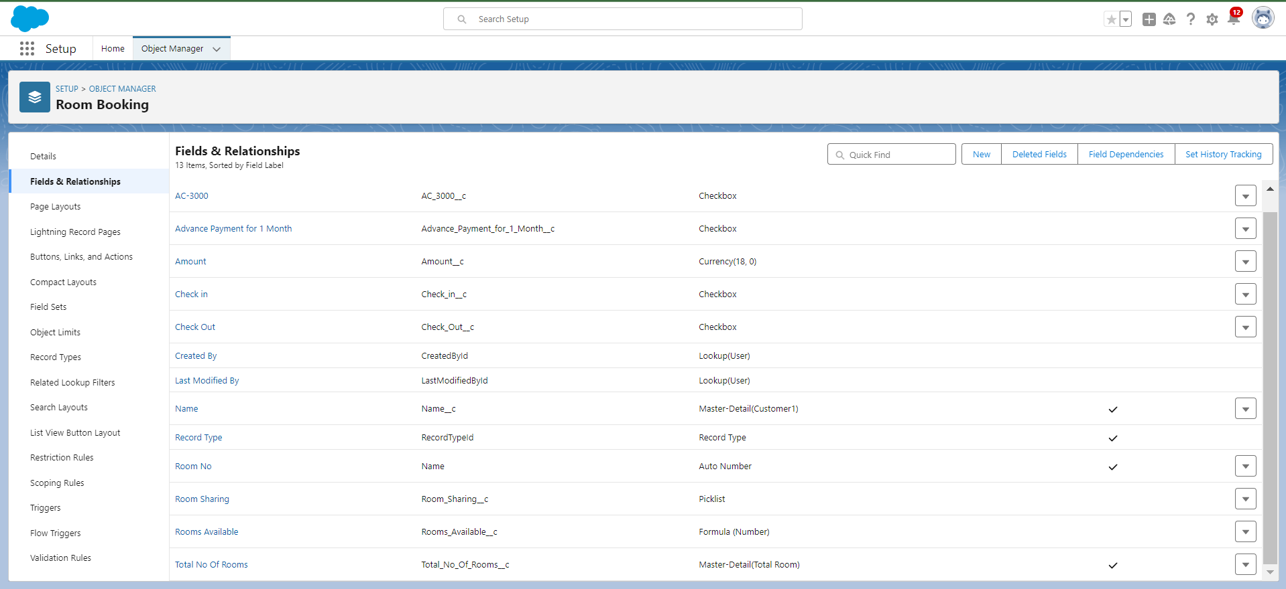

### **Creation of Fields & Relationship for Payment1 Object**

To create fields & relationship to an object:

Go to setup > click on Object Manager > type object name(Payment1) in the search bar > click on the object.

Now click on “Fields & Relationships” > New

Select Data Type as a “Master-detail Relationship”

Click on Next

Click on the Related to drop down and Select the Customer1 object and click on Next

Fill the Above as following:

Change the Field Label: Name

Field Name :It’s gets auto generated

Click on Next > Next > Save and new.

To create another fields & relationship to an object:

Go to setup > click on Object Manager > type object name(Payment1) in the search bar > click on the object.

Now click on “Fields & Relationships” > New

Select Data Type as a “Lookup Relationship”

Click on Next

Click on the Related to drop down and Select the Room Booking object and click on Next

Fill the Above as following:

Change the Field Label: Room Booking

Field Name :It’s gets auto generated

Click on Next > Next > Save and new.

 Creation of another fields for the Payment1 object

To create fields in an object:

Go to setup > click on Object Manager > type object name(Payment1) in the search bar > click on the object.

Now click on “Fields & Relationships” > New

Select Data Type as a “Picklist”

Fill the Above as following:

Field Label: Payment Mode

Value - Select enter values with each value separated by a new line

Cash

Check

Credit card

Debit card

UPI

Phonepe

Gpay

Paytm

Select required

Click on Next > Next > Save and new.

Cross Object Formula Field:

In Salesforce, a cross-object formula field allows you to create a formula that references fields from related objects. It enables you to perform calculations or display data from related records without the need for custom code or complex workflows.

Why do we need to create the Cross Object Formula Field:

If we want to get the Particular field from another object in that case we will use the Cross object Formula field. For that First we need to create the relationship b/w two objects and relate the field with formula data type.

Create a Cross object formula Field in Payment1 Object

Go to setup > click on Object Manager > type object name(Payment1) in the search bar > click on the object.

Now click on “Fields & Relationships” > New

Select Data Type as a “Formula”

Click on Next

Enter the Field label: Amount and Field name: gets auto generated and click on Next

In the Advanced Formula Click on the Insert field in the popup Screen Select the Payment1 and in the second drop down select the Room Booking and in the three drop down select the Amount field and click on Insert “ Room_Booking__r.Amount__c ”.

Click on the Check syntax: No syntax errors in merge fields

Click on Next > Next > Save and new.

**Screenshot:**

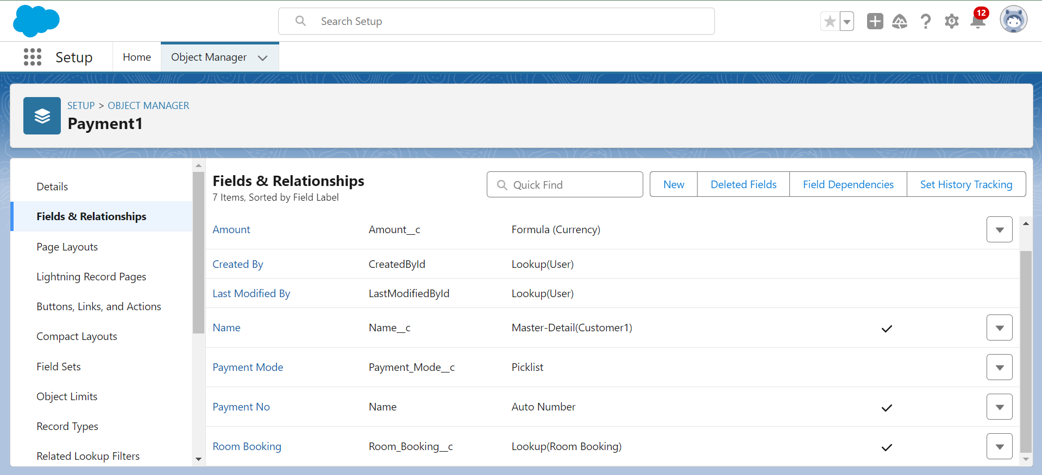

Creation of fields for the Food Selection object

1. To create fields & relationship to an object:

Go to setup > click on Object Manager > type object name(Room Booking) in the search bar > click on the object.

Now click on “Fields & Relationships” > New

Select Data Type as a “Master-detail Relationship”

Click on Next

Click on the Related to drop down and Select the Customer1 object and click on Next

Fill the Above as following:

Change the Field Label: Name

Field Name :It’s gets auto generated

Click on Next > Next > Save and new.

Picklist value sets:

Global picklist value sets let you share the values across objects. Base custom picklist fields on a global value set to inherit its values. The value set is restricted so users can’t add unapproved values through the API.

Create a picklist value set:

First click on gear icon and click on setup

Click on home tab in the Quick find box search for the “ Picklist value sets ”

Click on the Picklist value set and click on new

Enter the Label name and API name automatically Generate

Enter the values with each value separated by a new line

Sunday

Monday

Tuesday

Wednesday

Thursday

Friday

Saturday

Check the Use first value as default value and Click on save.

2. Create a picklist Field for Food selection object

To create fields in an object:

Go to setup > click on Object Manager > type object name(Food Selection) in the search bar > click on the object.

Now click on “Fields & Relationships” > New

Select Data Type as a “Picklist”

Fill the Above as following:

Field Label: Breakfast

Under Value - Select the Use global picklist value set

Under the drop down select the Custom Picklist Values

Select required

Click on Next > Next > Save and new.

3. Create a another picklist Field for Food selection object

To create fields in an object :

Go to setup > click on Object Manager > type object name(Food Selection) in the search bar > click on the object.

Now click on “Fields & Relationships” > New

Select Data Type as a “Picklist”

Fill the Above as following:

Field Label: Select Breakfast

Under Value - Enter values, with each value separated by a new line

Idli

Bonda

Dosa

Upma

Vada

Puri

Chapati

Select Checkbox Use First value as default Value

Click on Next > Next > Save and new.

Field Dependency:

A field dependency refers to a relationship between two fields on an object where the values of one field determine the available values for another field. Field dependencies are commonly used to create picklist field relationships, where the available options in a dependent picklist are determined by the value selected in a controlling picklist.

Need to use Field Dependency:

By using the field dependency we can get the different Values by selecting the different Picklist.

Create a Field Dependency on Breakfast and Select Breakfast Fields in Food Selection Object.

Go to setup > click on Object Manager > type object name(Food Selection) in the search bar > click on the object.

Now Click on fields & relationships and Click on Field Dependencies

Now Click on New Option

Under Controlling Field: Breakfast, Dependent Field: Select Breakfast and Click on Continue

Under the Sunday Ctrl and select the Picklist values Idli,Dosa,Puri and Click on Include Values in such a way that do for the remaining days and click on save.

4. To create fields in an object:

Go to setup > click on Object Manager > type object name(Food Selection) in the search bar ? click on the object.

Now click on “Fields & Relationships” > New

Select Data Type as a “Picklist”

Fill the Above as following:

Field Label: Lunch

Under Value - Select the Use global picklist value set

Under the drop down select the Custom Picklist Values

Select required

Click on Next > Next > Save and new.

5. To create fields in an object:

Go to setup > click on Object Manager > type object name(Food Selection) in the search bar > click on the object.

Now click on “Fields & Relationships” > New

Select Data Type as a “Picklist”

Fill the Above as following:

Field Label: Select Lunch

Under Value - Enter values, with each value separated by a new line

Meals

Chicken biryani

Veg biryani

Veg fried rice

Egg fried rice

Chicken fried rice

Curd rice

Tomato rice

Egg noodles

Chicken Noodles

Bhagara rice

Select Checkbox Use First value as default Value

Click on Next > Next > Save and new.

To create a Field dependencies for Lunch and Select Lunch.

Go to setup > click on Object Manager > type object name(Food Selection) in the search bar > click on the object.

Now Click on fields & relationships and Click on Field Dependencies

Now Click on New Option

Under Controlling Field:Lunch, Dependent Field: Select Lunch and Click on Continue

Under the Sunday Ctrl and select the Picklist values Chicken biryani, Egg fried rice, curd rice and Click on Include Values in such a way that do for the remaining days and click on save.

6. To create fields in an object:

Go to setup > click on Object Manager > type object name(Food Selection) in the search bar > click on the object.

Now click on “Fields & Relationships” > New

Select Data Type as a “Picklist”

Fill the Above as following:

Field Label: Dinner

Under Value - Select the Use global picklist value set

Under the drop down select the Custom Picklist Values

Select required

Click on Next > Next > Save and new.

7. To create fields in an object:

Go to setup > click on Object Manager > type object name(Food Selection) in the search bar > click on the object.

Now click on “Fields & Relationships” > New

Select Data Type as a “Picklist”

Fill the Above as following:

Field Label: Select Dinner

Under Value - Enter values, with each value separated by a new line

Meals

Chicken biryani

Veg biryani

Veg fried rice

Egg fried rice

Chicken fried rice

Curd rice

Tomato rice

Egg noodles

Chicken Noodles

Bhagara rice

Select Checkbox Use First value as default Value

Click on Next > Next > Save and new.

To create a Field dependencies for Dinner and Select Dinner.

Go to setup > click on Object Manager > type object name(Food Selection) in the search bar > click on the object.

Now Click on fields & relationships and Click on Field Dependencies

Now Click on New Option

Under Controlling Field: Dinner, Dependent Field: Select Dinner and Click on Continue

Under the Sunday Ctrl and select the Picklist values Chicken biryani, curd rice, Chicken noodles and Click on Include Values in such a way that do for the remaining days and click on save.

**Screenshot:**

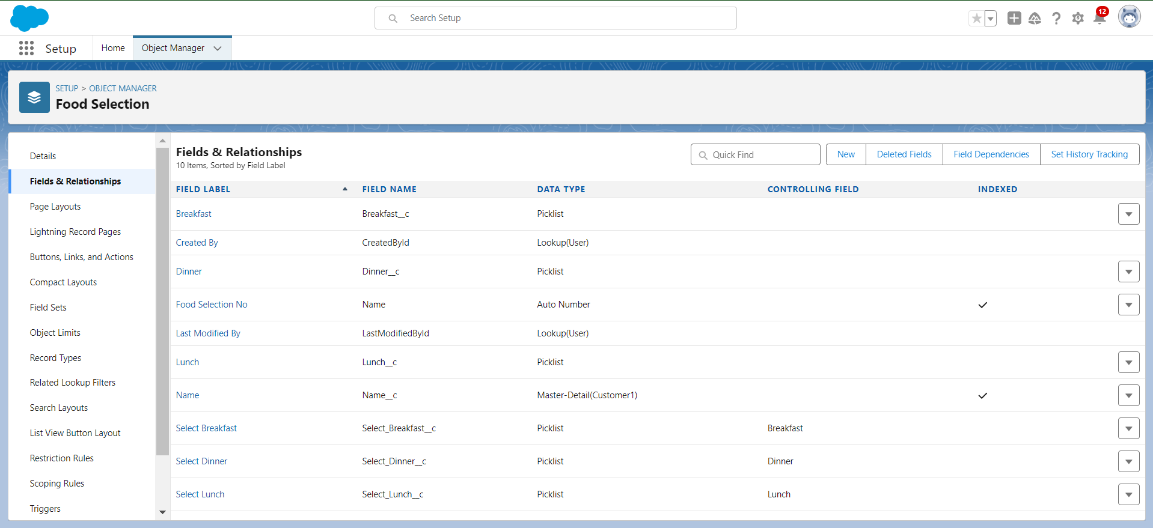

Creation of fields for the Feedback object

1. create fields & relationship to an object:

Go to setup > click on Object Manager > type object name(Feedback) in search bar > click on the object.

Now click on “Fields & Relationships” > New

Select Data Type as a “Lookup Relationship”

Click on Next

Click on the Related to drop down and Select the Customer1 object and click on Next

Fill the Above as following:

Change the Field Label: Name

Field Name :It’s gets auto generated

Click on Next > Next > Save and new.

2. To create Another fields in an Same object:

Go to setup > click on Object Manager > type object name(Feedback) in search bar > click on the object.

Now click on “Fields & Relationships” > New

Select Data Type as a “Picklist”

Click on Next

Fill the Above as following:

Field Label: Roomcleaning

Field Name :It’s gets auto generated

Under Values select Enter values, with each value separated by a new line

Good

Satisfaction

Bad

Click on Next > Next > Save and new.

3. To create a Another Fields in an Same Object

Go to setup > click on Object Manager > type object name(Feedback) in search bar > click on the object.

Now click on “Fields & Relationships” ? New

Select Data Type as a “Picklist”

Click on Next

Fill the Above as following:

Field Label: Internet

Field Name :It’s gets auto generated

Under Values select Enter values, with each value separated by a new line

Good

Satisfaction

Bad

Click on Next > Next > Save and new.

4. To create a Another Fields in an Same Object

Go to setup > click on Object Manager > type object name(Feedback) in search bar > click on the object.

Now click on “Fields & Relationships” ? New

Select Data Type as a “Picklist”

Click on Next

Fill the Above as following:

Field Label: Food

Field Name :It’s gets auto generated

Under Values select Enter values, with each value separated by a new line

Good

Satisfaction

Bad

Click on Next > Next > Save and new.

5. To create a Another Fields in an Same Object

Go to setup > click on Object Manager > type object name(Feedback) in search bar > click on the object.

Now click on “Fields & Relationships” > New

Select Data Type as a “Text area”

Click on Next

Fill the Above as following:

Field Label: Suggestion

Field Name :It’s gets auto generated

Click on Next > Next > Save and new.

**Screenshot:**

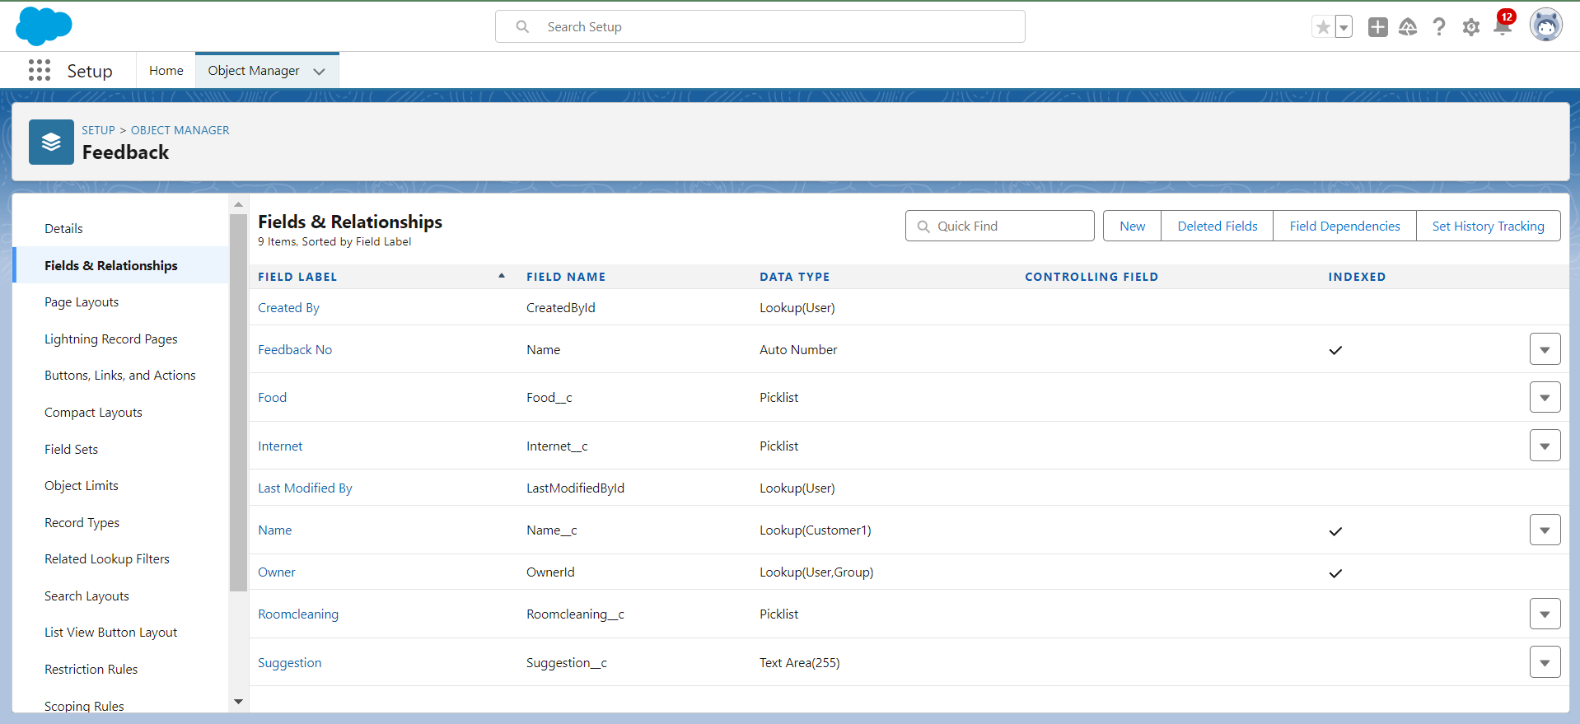

### **Creation of fields for the Total Rooms object**

1. To create fields in an object:

Go to setup > click on Object Manager > type object name(Total Rooms) in search bar > click on the object.

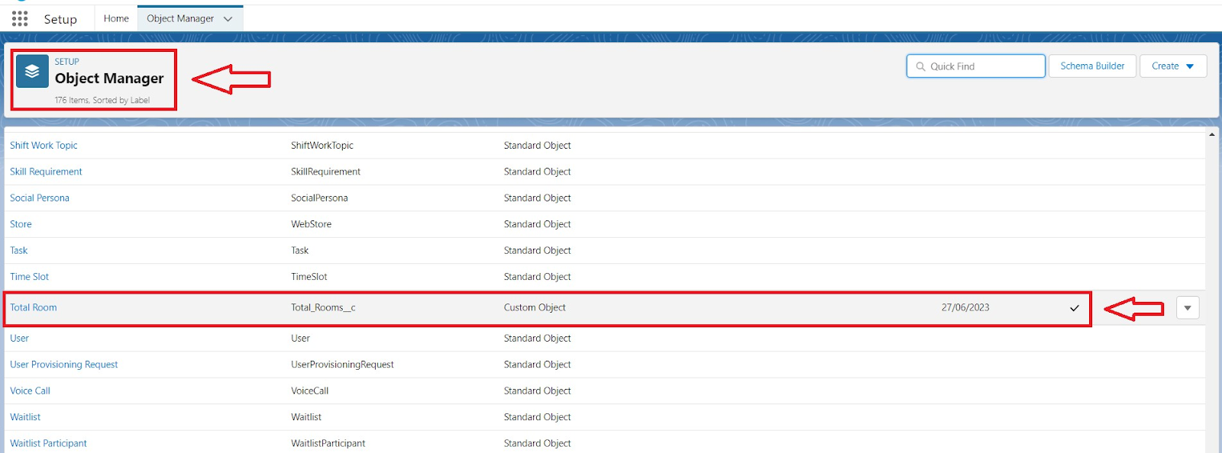

Now click on “Fields & Relationships” > New

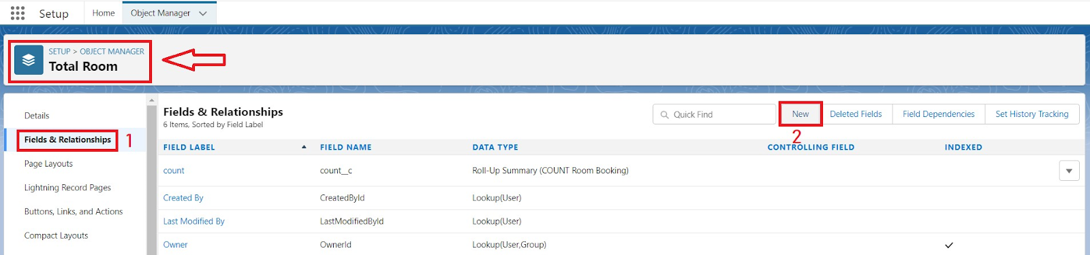

Select Data type as a “Formula” and Click on Next

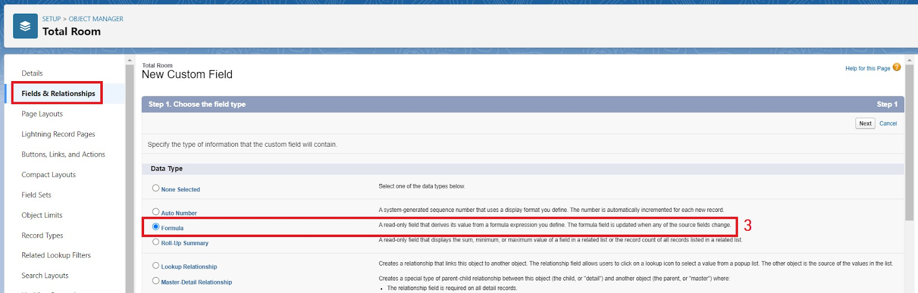

Fill the Above as following:

Field Label: Rooms Available

Field Name : It’s gets auto generated

Select the Formula Return Type as “Number”

Select the Decimal places as “0” and Click on Next

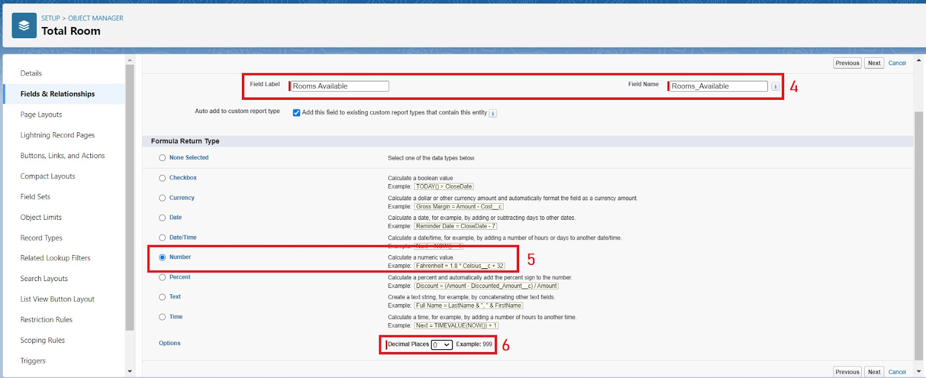

Note: I am Considering “Total No Of Rooms = 30” While creating a new record in Total Rooms Object.

Click on the Advanced Formula “ 30 -  Rooms_Booked__c ” and Check Syntax

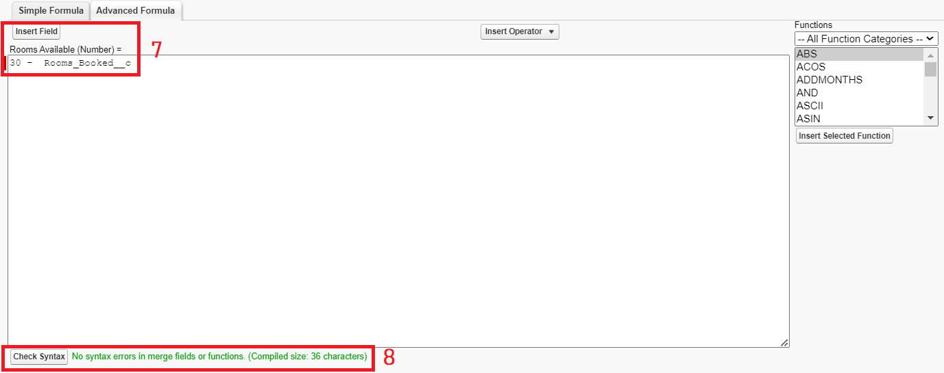

Click on Next > Next > Save and new.

**Screenshot:**

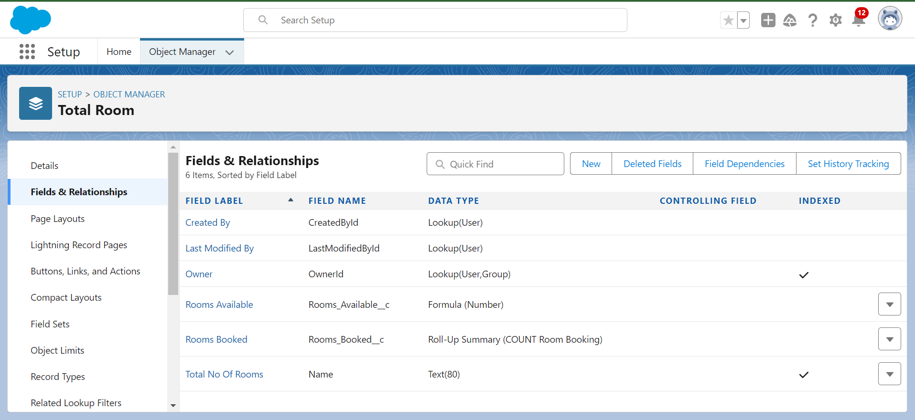

**Task 6:**

### **create a validation rule to an Room Booking Object**

Go to setup > click on Object Manager > type object name(Room Booking) in the search bar > click on the object.

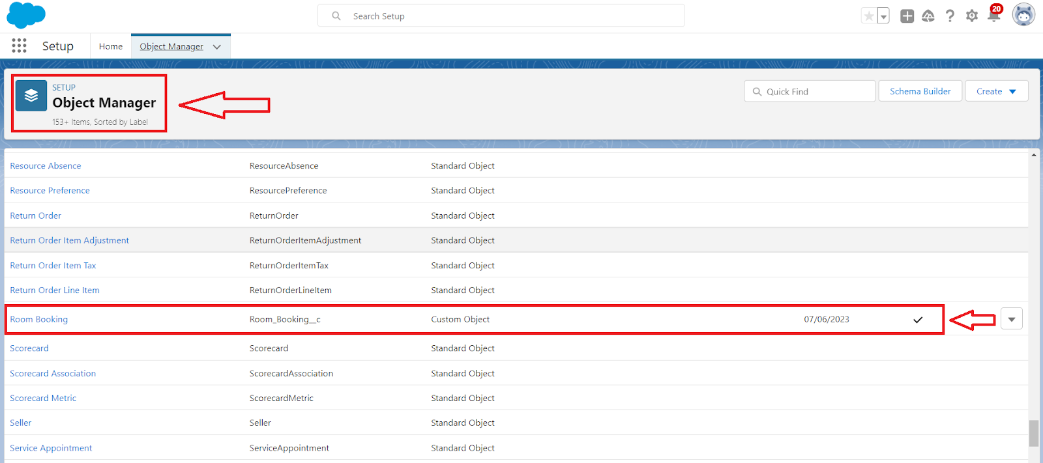

Now click on “Validation rule” at top > New.

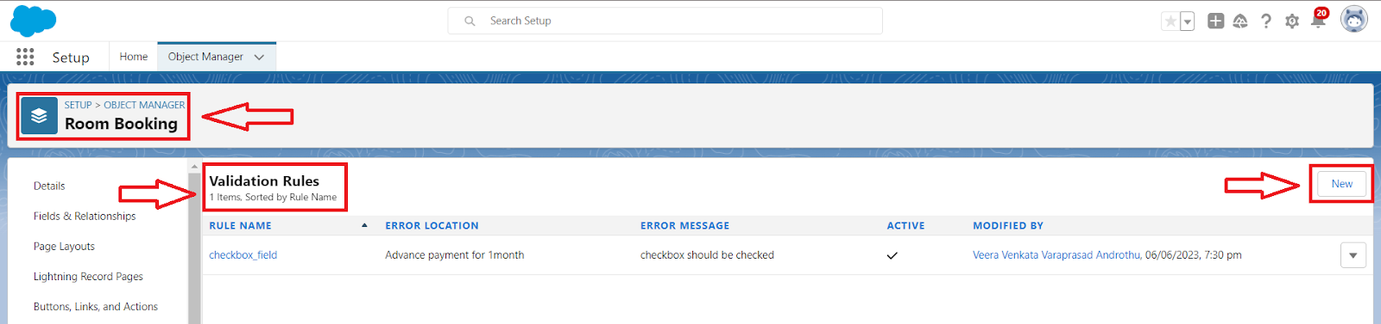

Enter Rule name “checkbox field” and make the validation should be Active.

Enter the formula in the formula Box “Advance_payment_for_1month__c  = false” and check for syntax error.

Enter the error message “Checkbox should be checked”

Select error location as field(Advance payment for 1month)

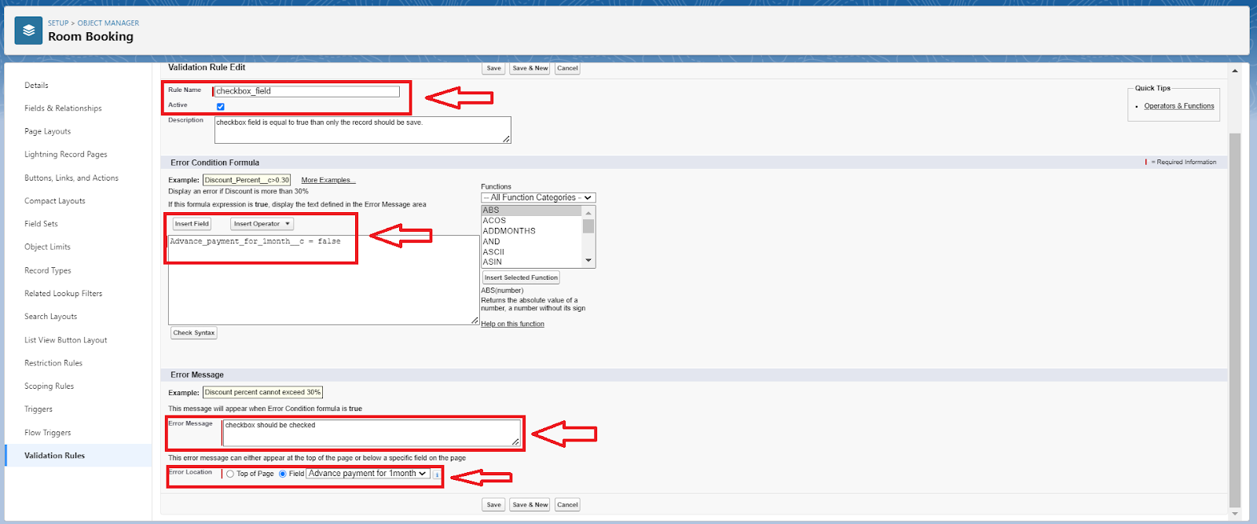

Click on save.

**Screenshot:**

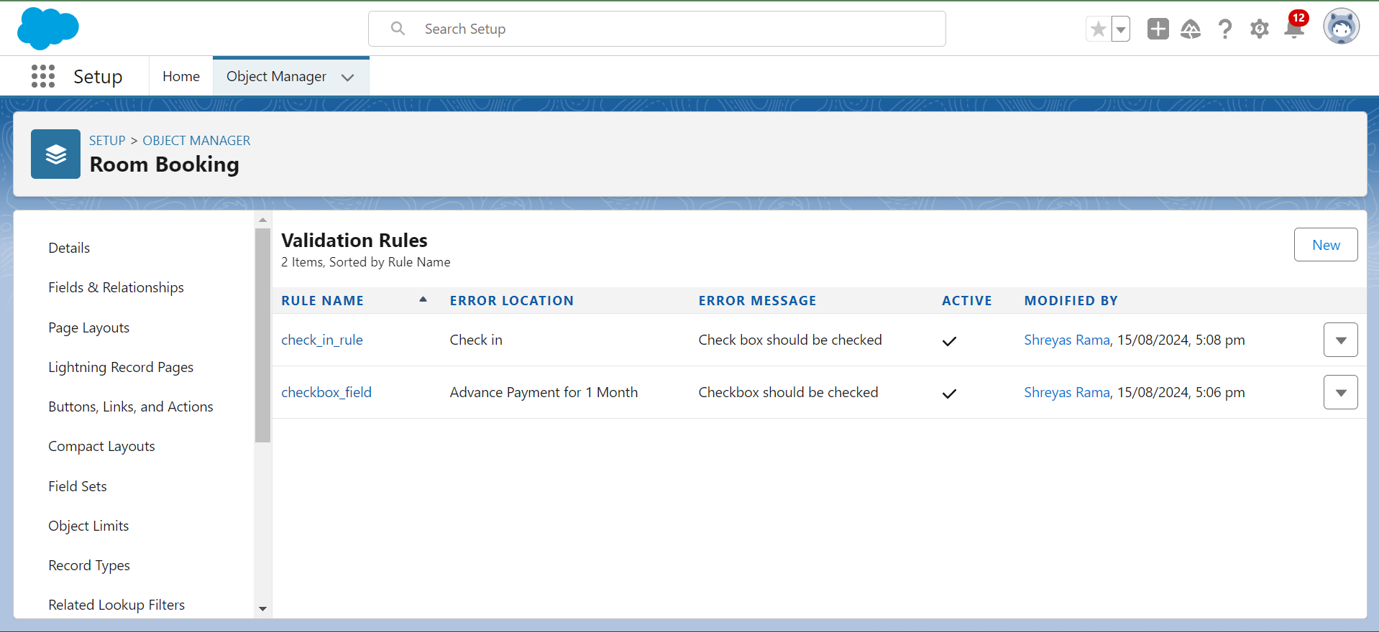

### **Create a Another validation rule to an Room Booking Object**

Go to setup > click on Object Manager > type object name(Room Booking) in the search bar > click on the object.

Now click on “Validation rule” at top > New.

Enter Rule name “check in rule” and make the validation should be Active.

Enter the formula in the formula Box “ Check_in__c = False ” and check for syntax error

Enter the error message “Check box should be checked”

Select error location as field(Check in)

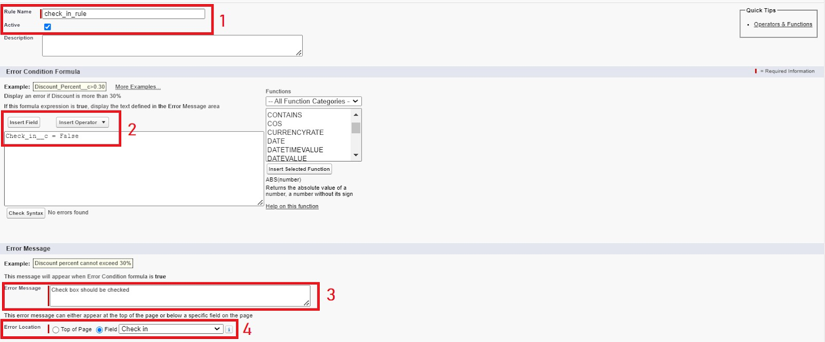

Click on save.

**Screenshot:**

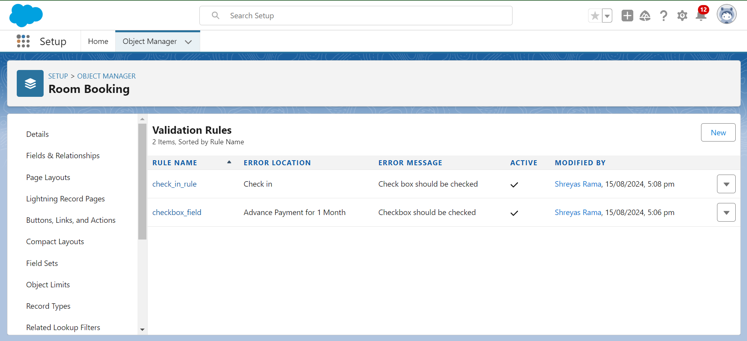

**Task 7:**

### **Custom user Profile**

To create a new profile:

Go to setup > type profiles in quick find box > click on profiles > clone the desired profile (Standard User)

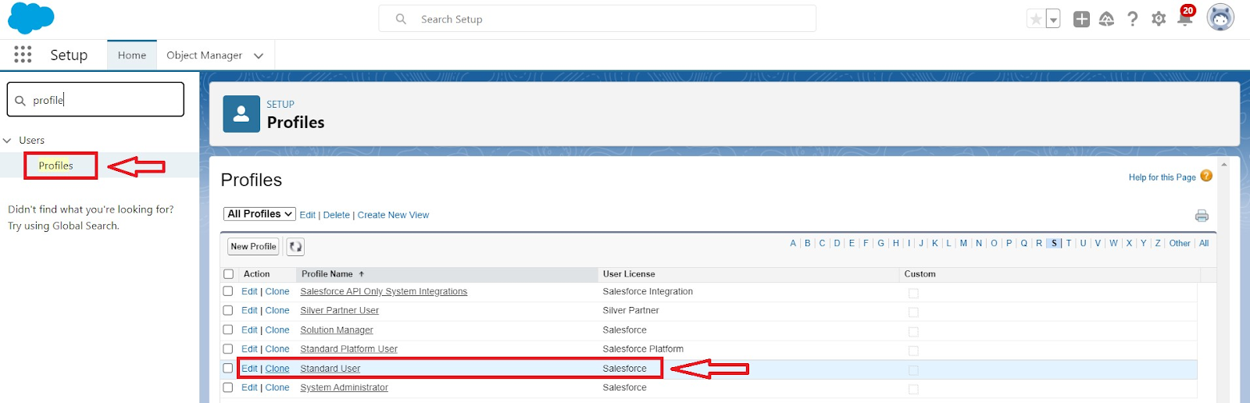

Enter profile name (Custom User) > Save.

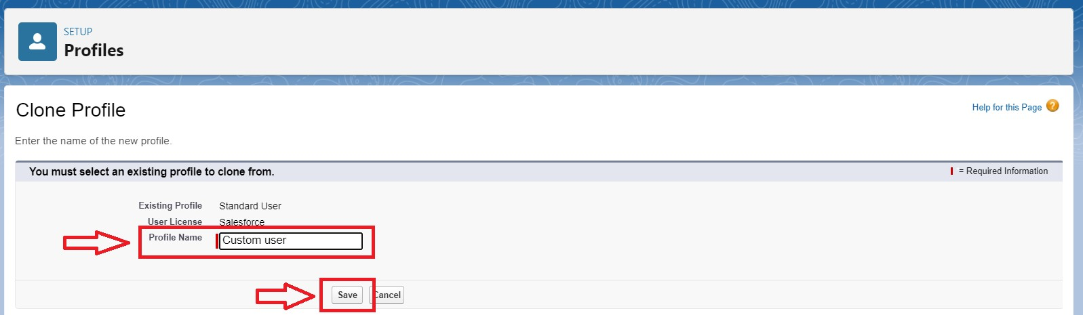

While still on the profile page, then click Edit.

Scroll down to Custom Object Permissions and Give All access permissions for Customers, Feedbacks, Food selections, Payments, Room Bookings and Total Rooms.

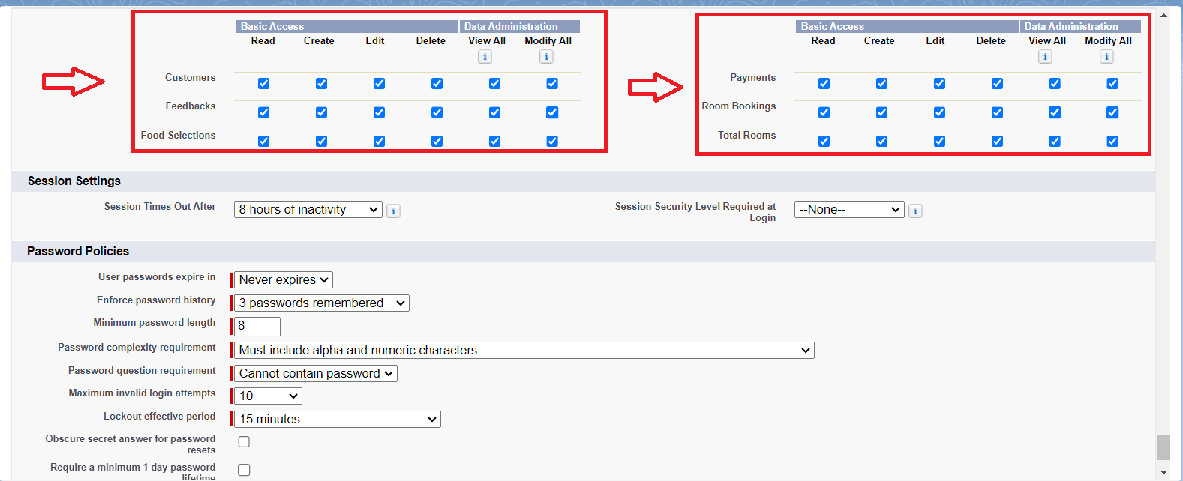

Scroll down and Click on Save.

**Screenshot:**

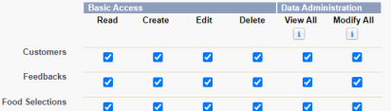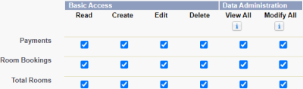

### **Custom platform user1**

To create a new profile:

Go to setup > type profiles in quick find box > click on profiles > clone the desired profile (Standard platform User)

Enter profile name (Custom platform User1) > Save.

While still on the profile page, then click Edit.

Scroll down to Custom Object Permissions and Give only Read access permissions for Customers, Feedbacks, Food selections, Payments, Room Bookings and Total Rooms.

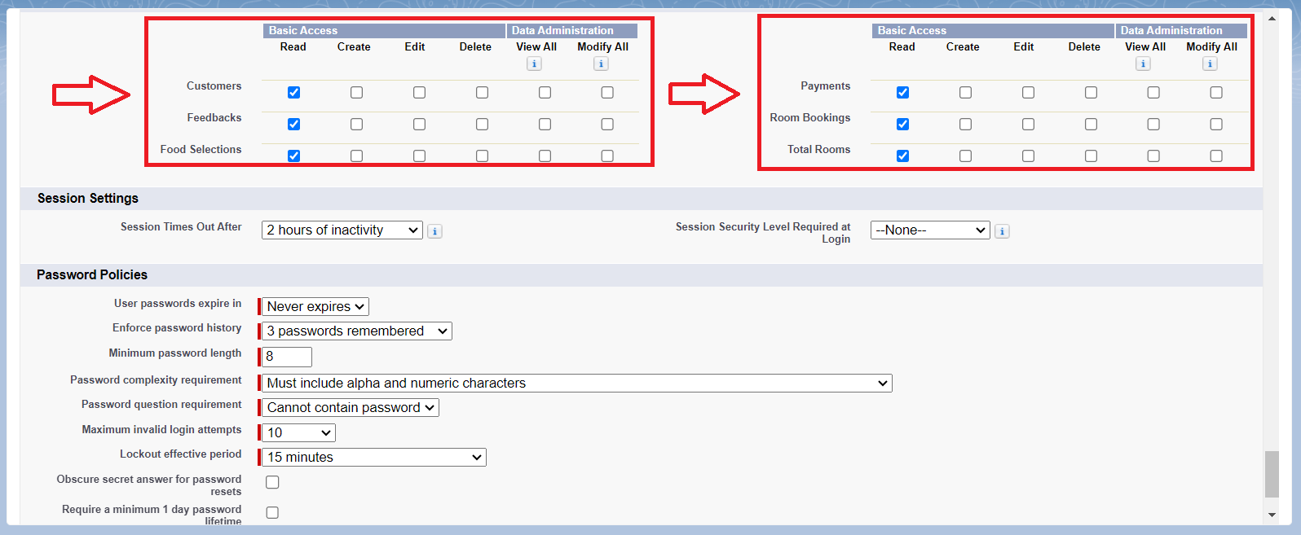

Scroll down and Click on Save.

**Screenshot:**

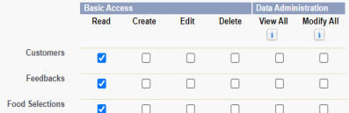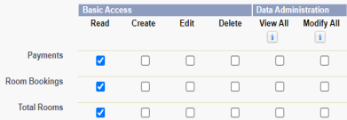

### **Custom platform user2**

To create a new profile:

Go to setup > type profiles in quick find box > click on profiles > clone the desired profile (Standard platform User)

Enter profile name (Custom platform User2) > Save.

While still on the profile page, then click Edit.

Scroll down to Custom Object Permissions and Give Create, Read, Edit and Delete access permissions for Customers, Feedbacks, Food selections, Payments and Room Bookings. And Read Access permission for Total Rooms Object.

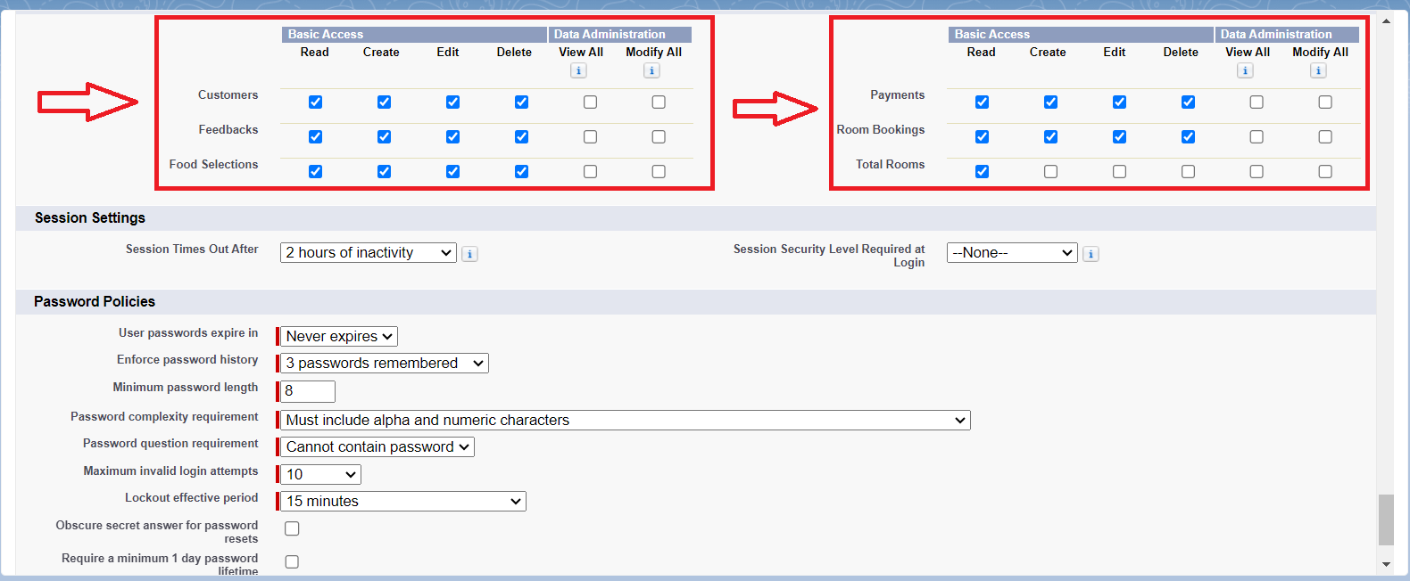

Scroll down and Click on Save.

**Screenshot:**

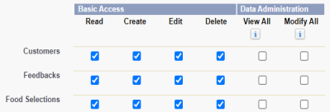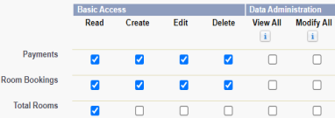

**Task 8:**

### **Marketing Role**

Go to quick find > Search for Roles > click on set up roles.

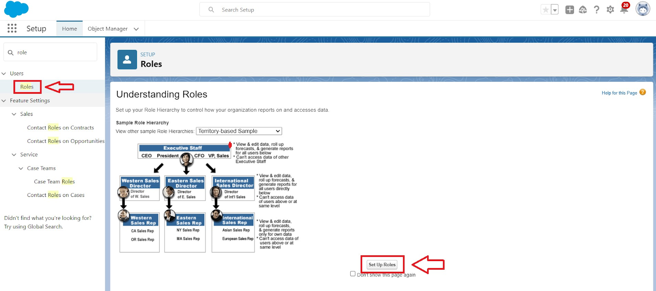

Click on Expand All and click on add role under CEO role.

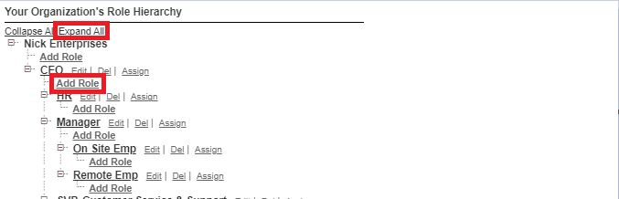

Give Label as “Marketing” and Role name gets auto populated.

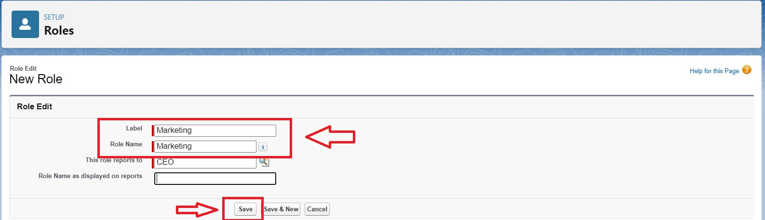

Then click on Save.

V

**Screenshot:**

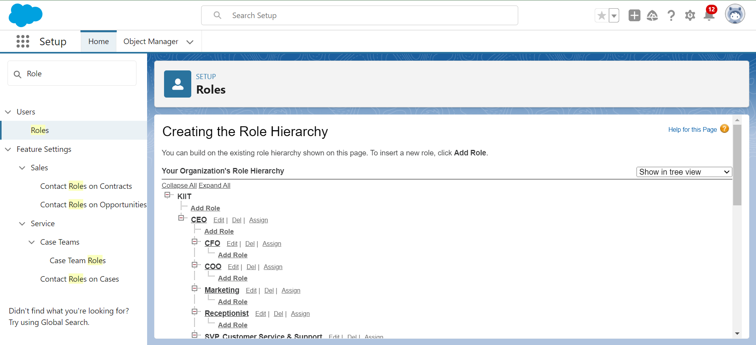

### **Receptionist Role**

Go to quick find > Search for Roles > click on set up roles.

Click on Expand All and click on add role under CEO role.

Give Label as “Receptionist” and Role name gets auto populated.

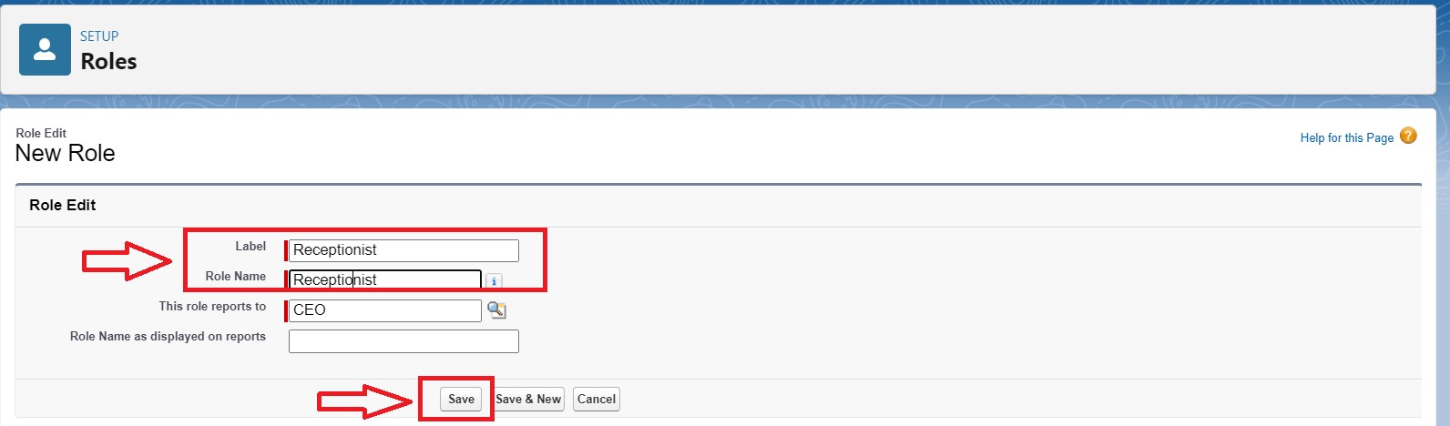

Then click on Save.

**Screenshot:**

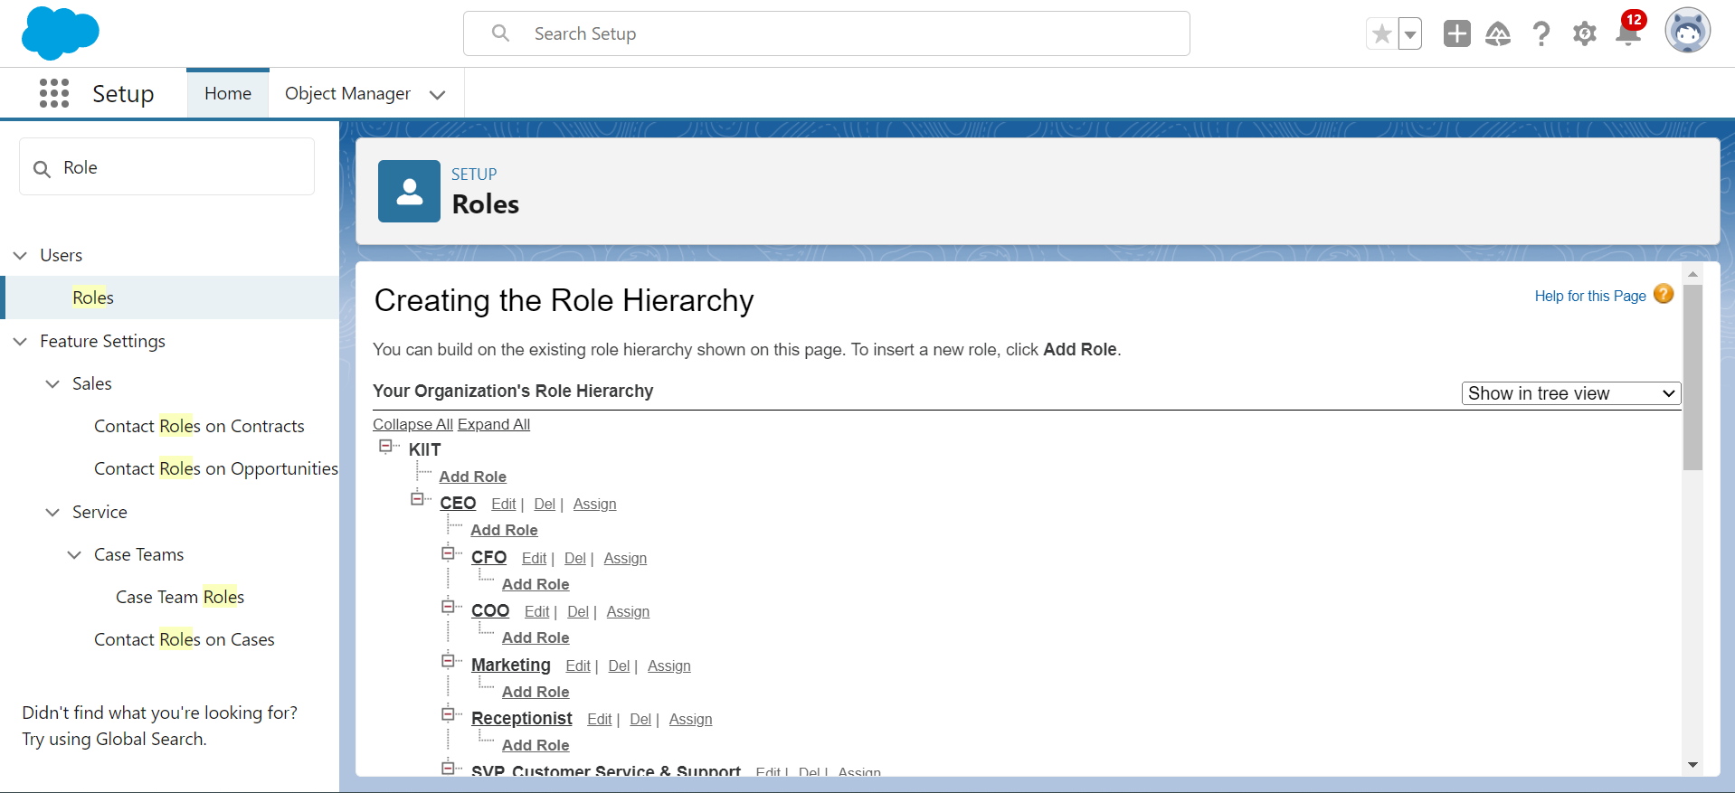

**Task 9:**

### **Create User**

Go to setup > type users in quick find box > select users > click New user.

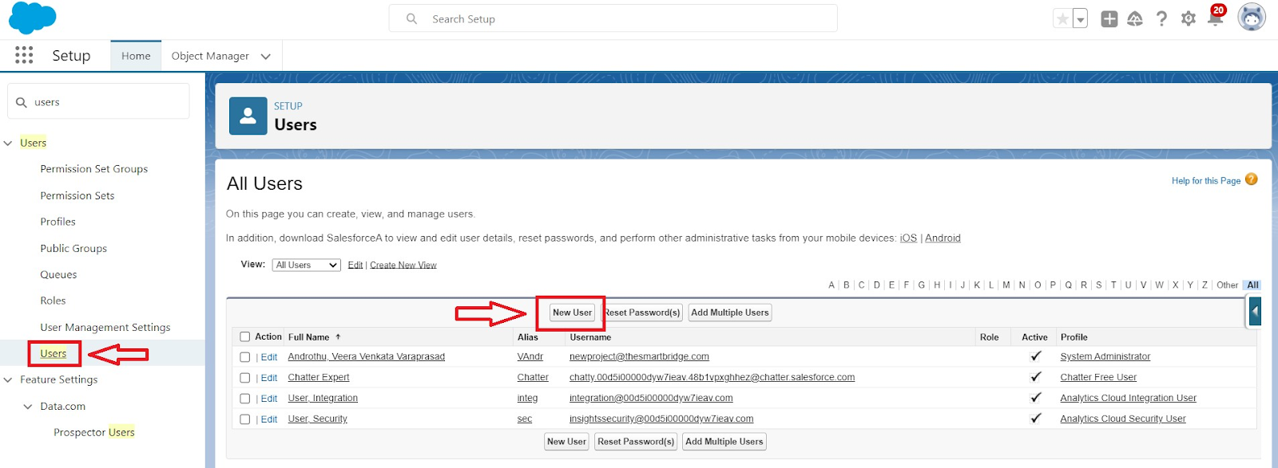

Fill in the fields

First Name : sandeep

Last Name : gujja

Alias : Give a Alias Name

Email id : Give your Personal Email id

Username : Username should be in this form: text@text.com

Nick Name : Give a Nickname

Role   : CEO

User licence : Salesforce

Profiles   : Custom user

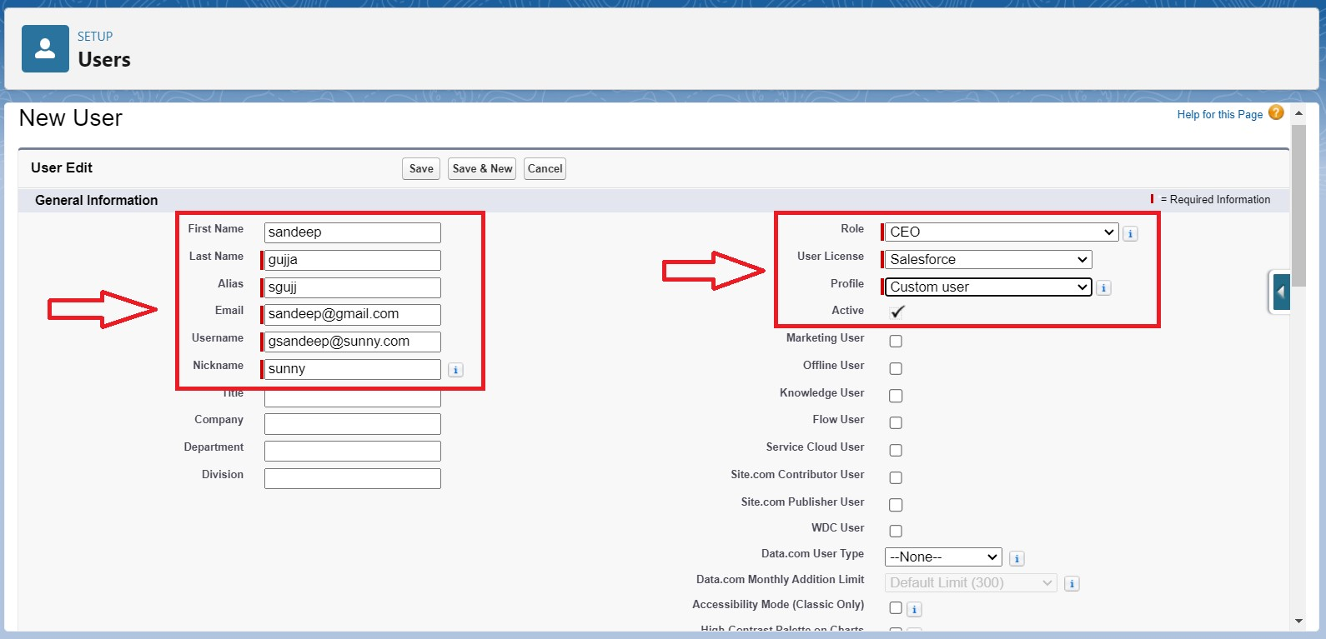

save.

**Screenshot:**

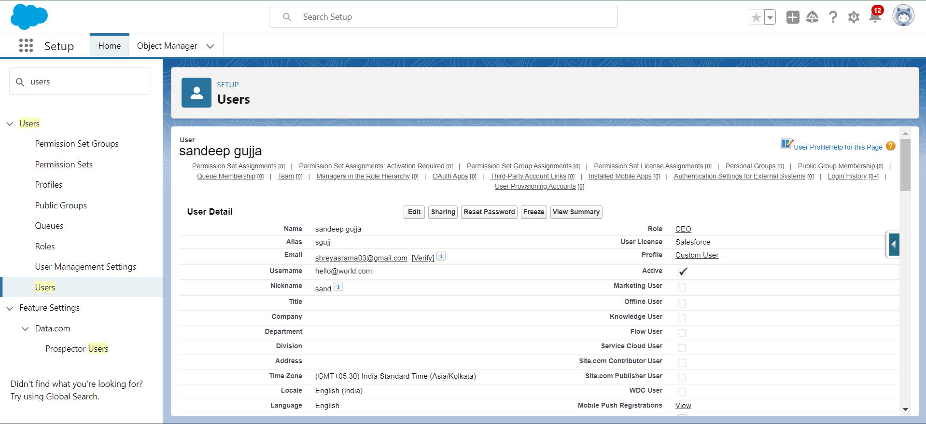

### **Create Another User**

Go to setup > type users in quick find box > select users > click New user.

Fill in the fields

First Name : Abhilash

Last Name : garapati

Alias           : Give a Alias Name

Email id : Give your Personal Email id

Username : Username should be in this form: text@text.com

Nick Name : Give a Nickname

Role : Marketing

User licence: Salesforce platform

Profiles : Custom Platform User1

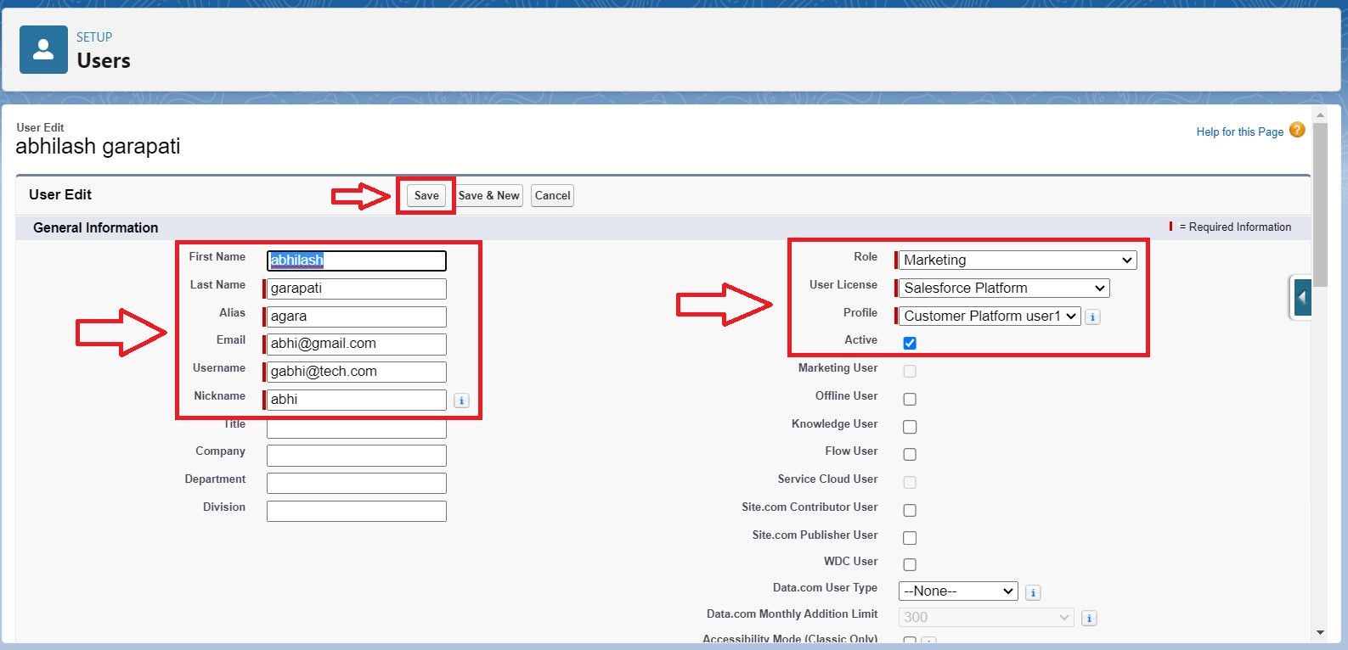

save

**Screenshot:**

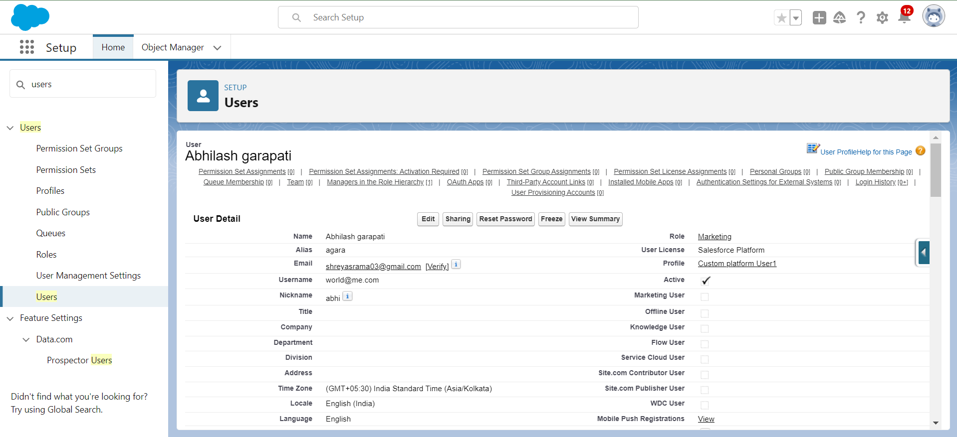

### **Create Another User**

Go to setup > type users in quick find box > select users > click New user.

Fill in the fields

First Name : Ganesh

Last Name : gelli

Alias : Give a Alias Name

Email id : Give your Personal Email id

Username : Username should be in this form: text@text.com

Nick Name: Give a Nickname

Role : Receptionist

User licence: Salesforce Platform

Profiles : Custom Platform user2

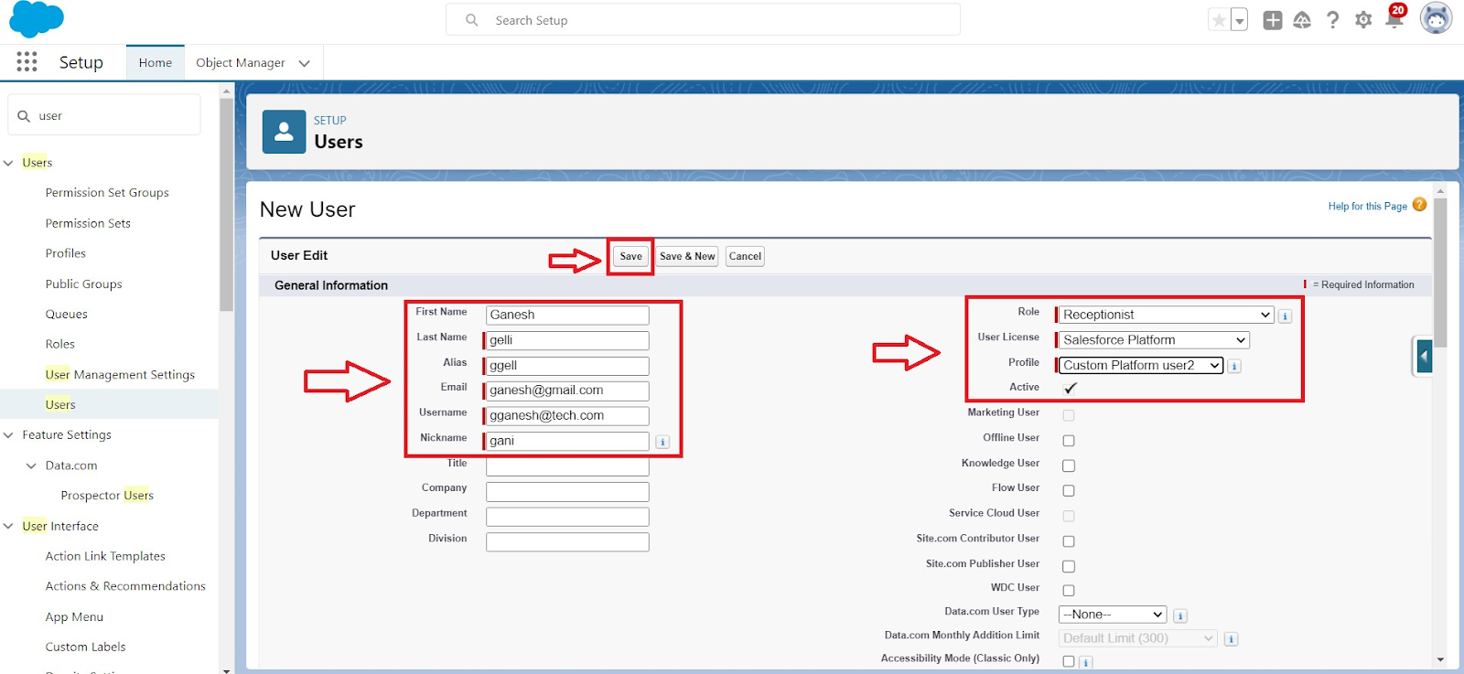

Save

**Screenshot:**

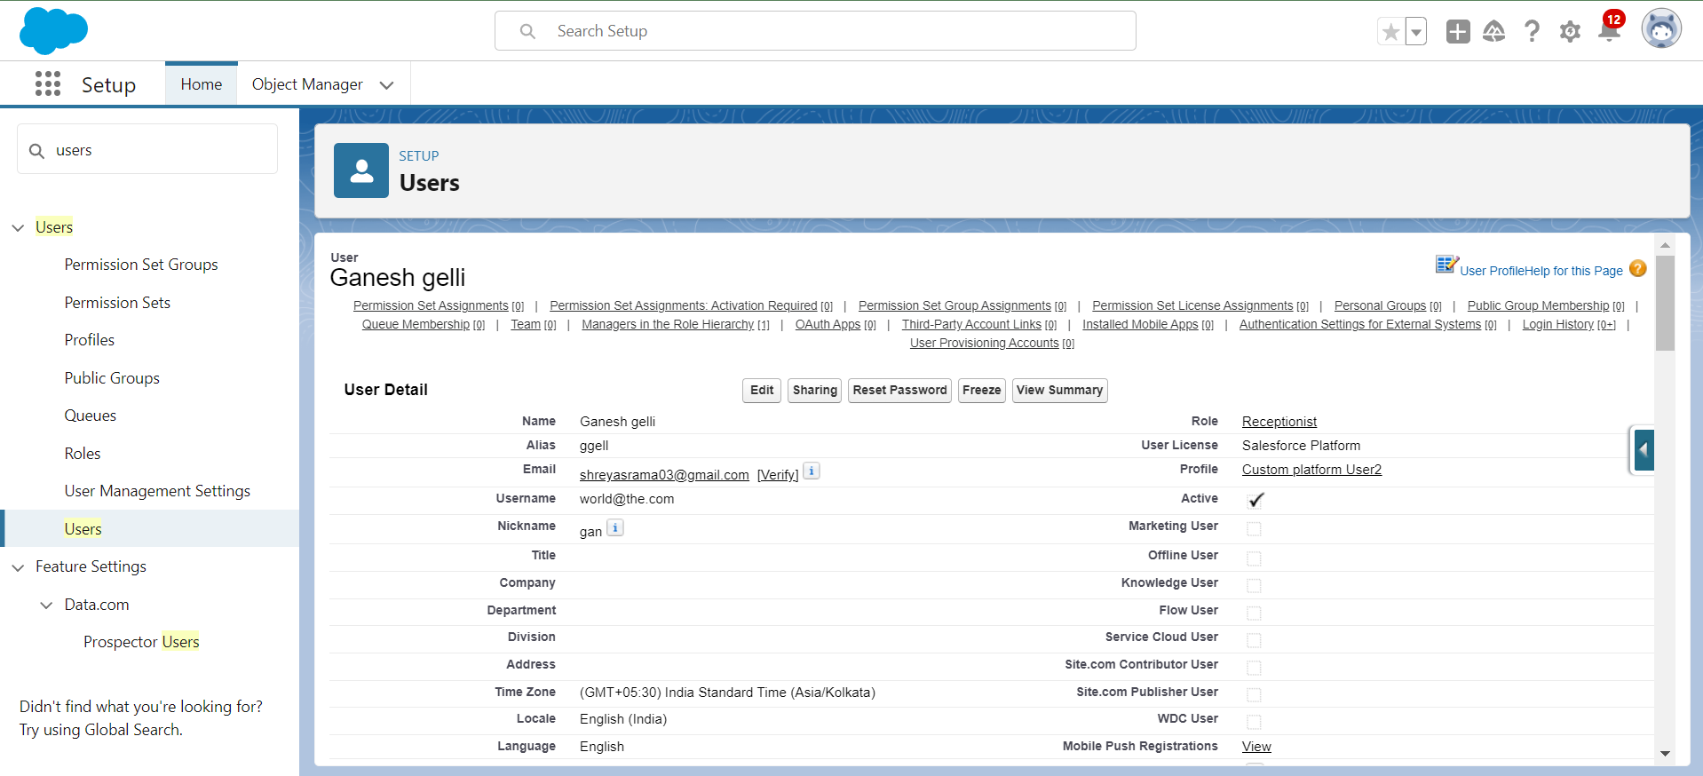

**Task 10:**

### **Create a Record (Customers)**

Click on App Launcher on the left side of the screen.

Search Home Feels & click on it.

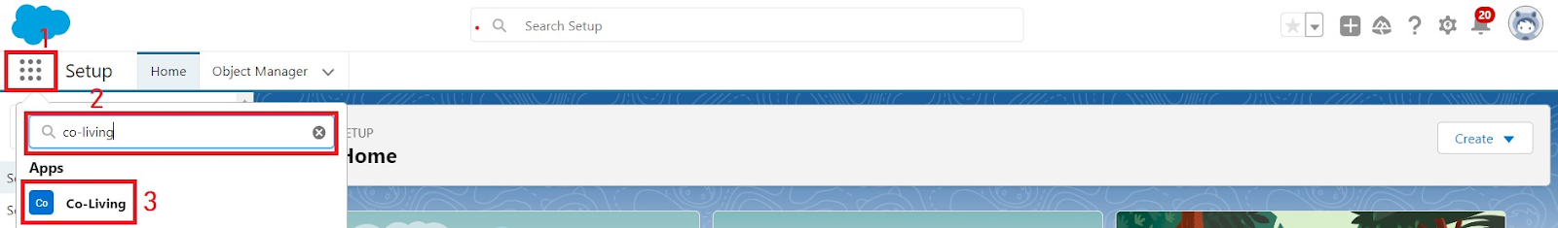

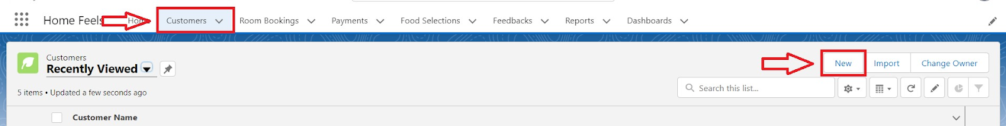

Click on the Customers Tab.

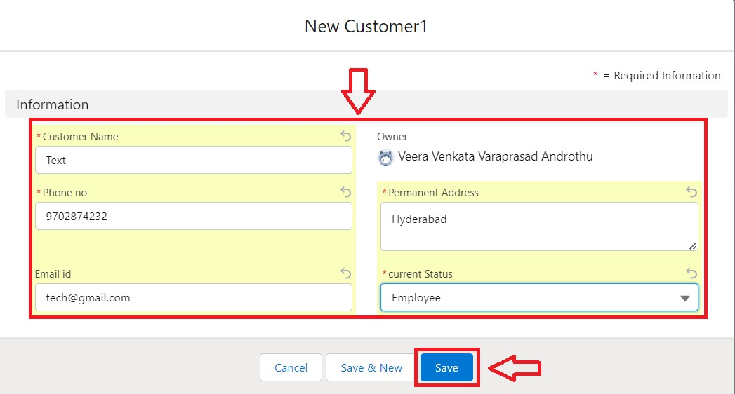

Click new and fill details & Save

**Screenshot:**

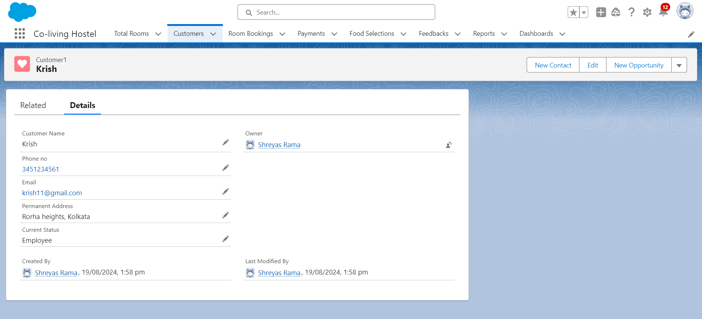

### **View a Record (Customers)**

Click on App Launcher on the left side of the screen.

Search Home Feels & click on it.

Click on Customer Tab.

Click on any record name. you can see the details of the Customer.

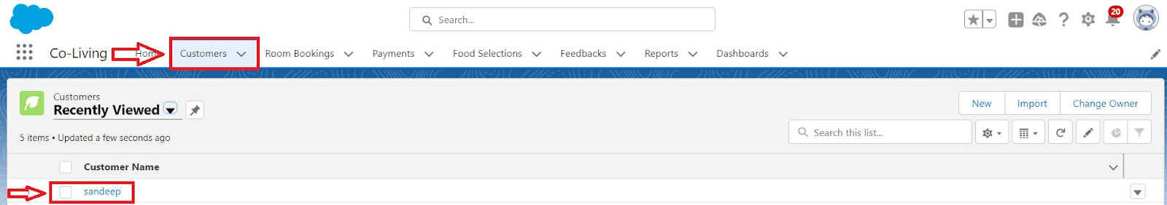

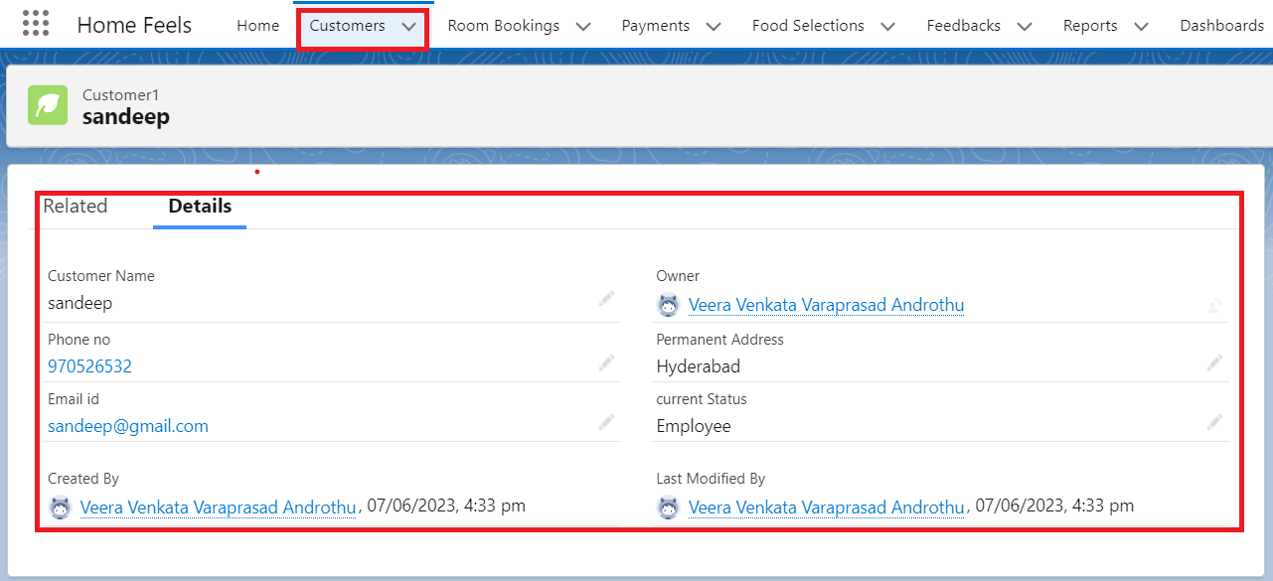

### **Delete a Record (Customers)**

Click on App Launcher on the left side of the screen.

Search Home Feels & click on it.

Click on the Customers Tab.

Click on Arrow at right hand side on that Particular record.

Click delete and delete again.

**Task 11:**

Create Report

Go to the app > click on the reports tab

Click New Report.

Select report type from category or from report type panel or from search panel “Customers with Room Bookings with Total Rooms ” > click on start report.

Customize your report

Add fields from left pane as shown below

Save or run it.

**Screenshot:**

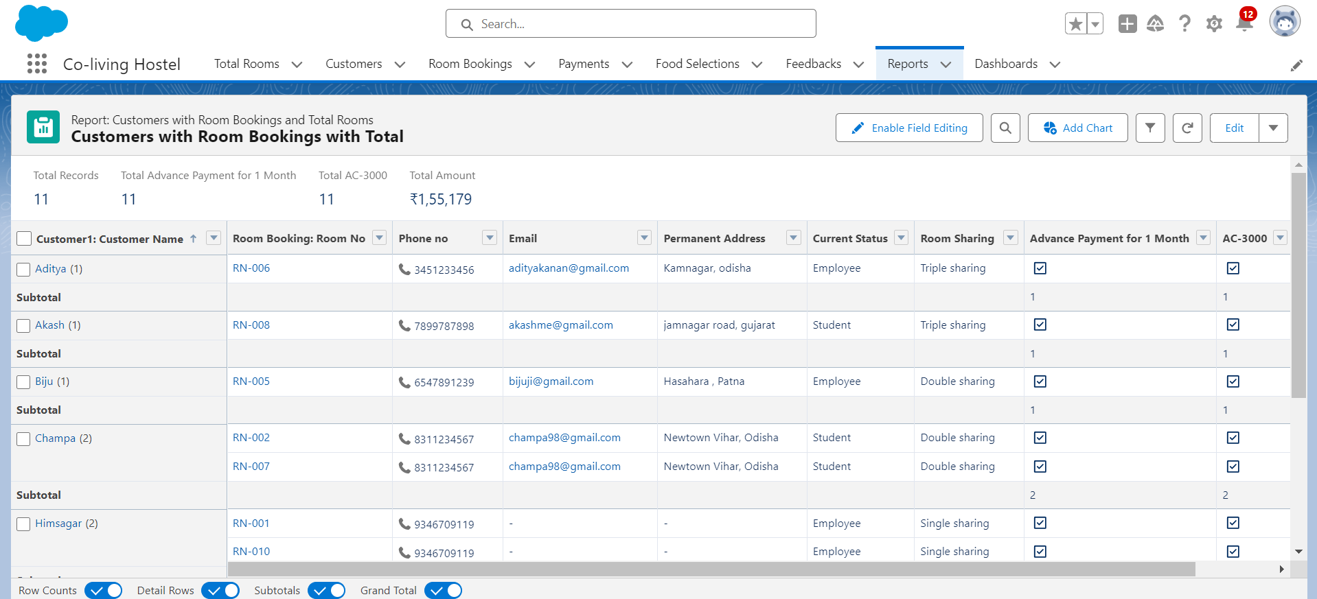

**Create another Report**

Go to the app > click on the reports tab

Click New Report.

Select report type from category or from report type panel or from search panel Select customer with Room booking with Payments ? click on start report.

Customize your report

Add fields from left pane as shown Above

Save or run it.

**Screenshot:**

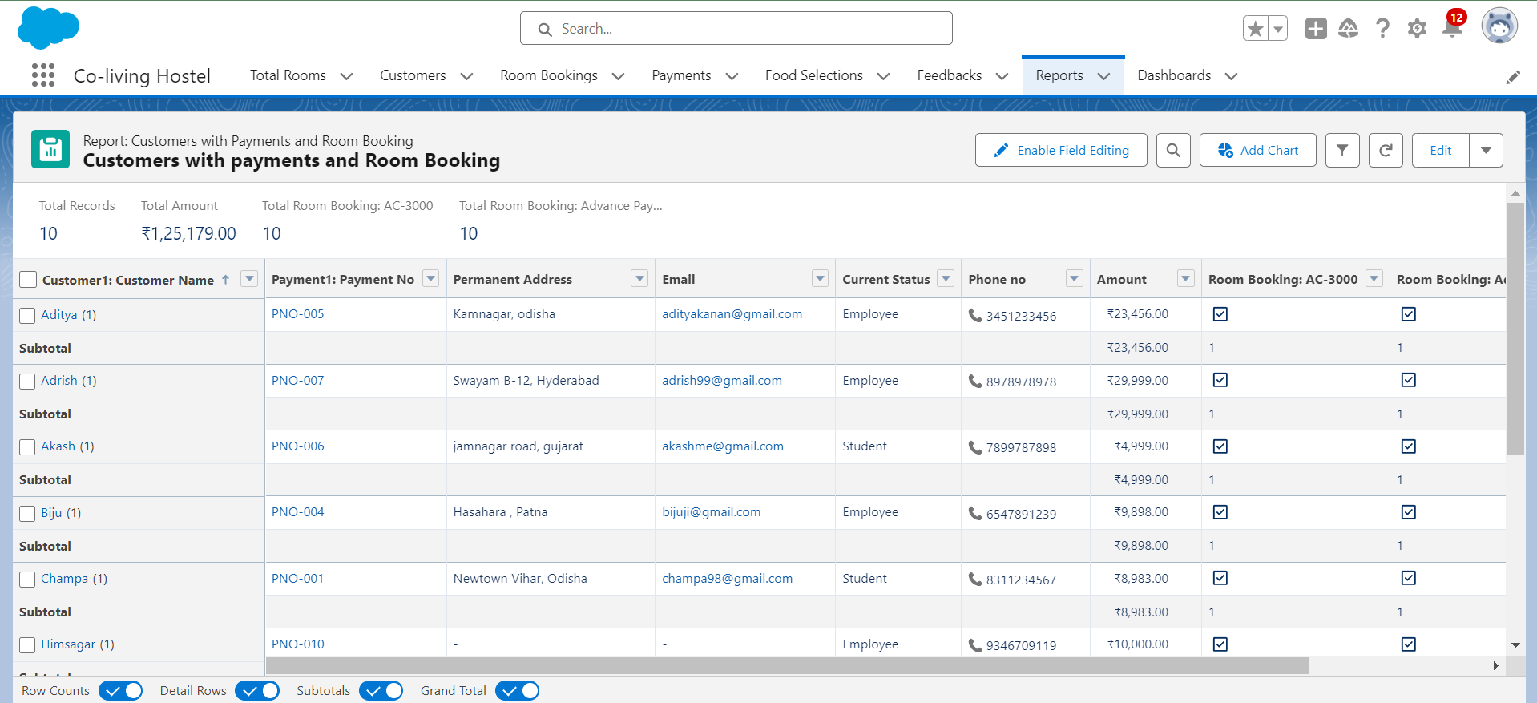

**Task 12:**

### **Create Dashboard**

Go to the app > click on the Dashboard tabs and click on new Dashboard

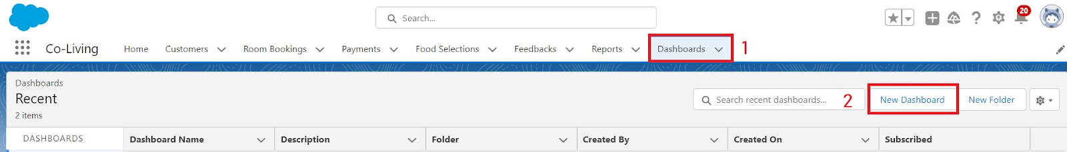

Give a Name and click on Create.

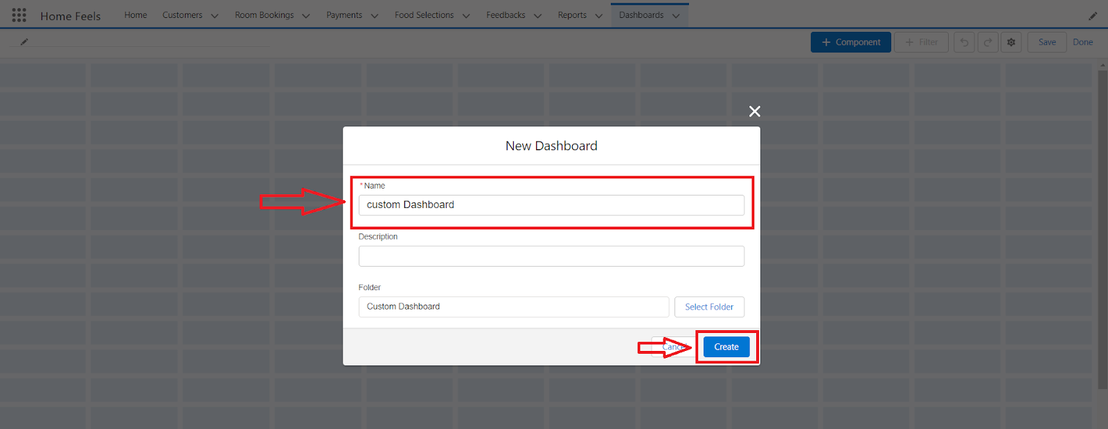

Select add component.

Select a Report Customer with Room Booking and click on select.

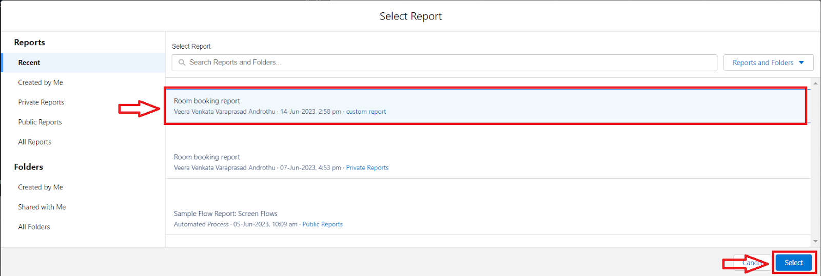

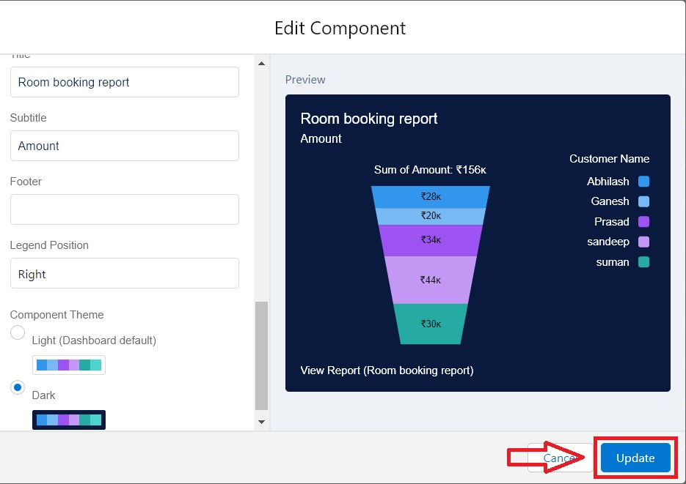

Click Add then click on Save and then click on Done.

**Screenshot:**

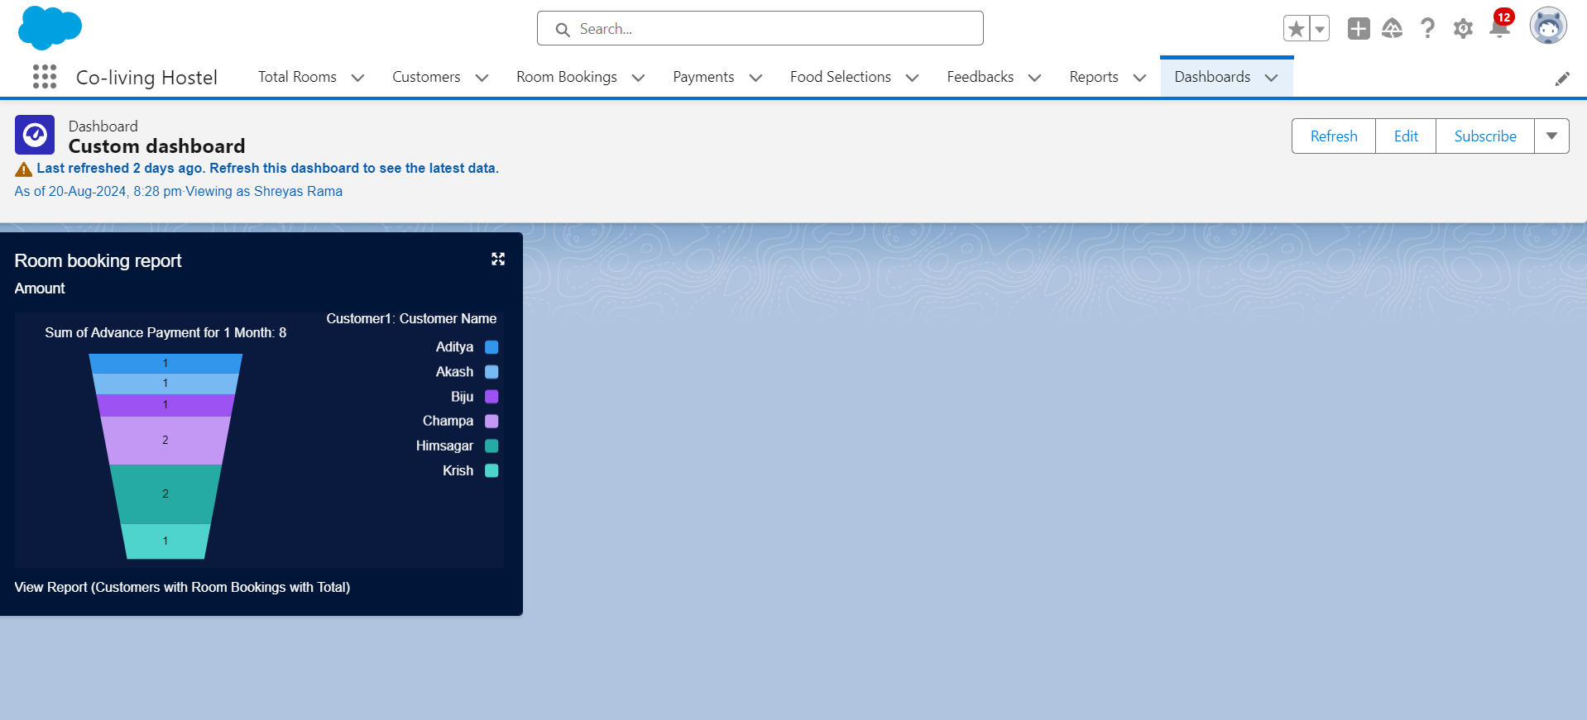

**Create Another Dashboard**

Go to the app > click on the Dashboard tabs and click on new Dashboard.

Give a Name and click on Create.

Select add component.

Select a Report Customer with Room Booking with Payments and click on select.

Click Add then click on Save and then click on Done.

**Screenshot:**

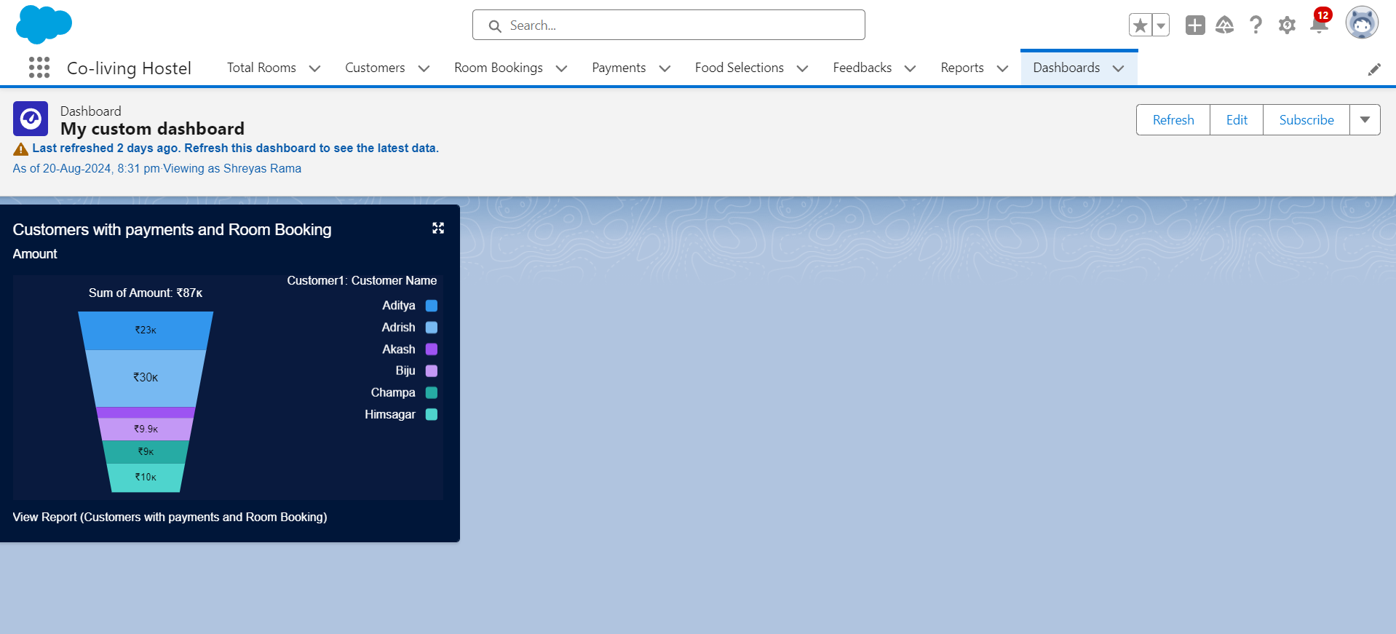

**Task 13:**

Create a Flow

Go to setup > type Flow in quick find box > Click on the Flow and Select the New Flow.

Select the Record-triggered flow and Click on Create.

Select the Object as a Room Booking in the Drop down list.

Select the Trigger Flow when: “A record is Created or Updated”.

Select the Optimize the flow for: “Actions and Related Records” and Click on Done.

Under the Record-triggered Flow Click on “+” Symbol and In the Drop down List select the “Decision Element”.

Enter the Details Label: Field should be Update, API name: Gets Automatically Generated.

Enter the Outcome Details Label: Single sharing, Outcome API name: Gets Automatically Generated.

Resource: Select Record.Room sharing.

Operator: Select Equals.

Value: Select Single sharing.

Click on “Add Condition”

Resource: Select Record.AC-3000.

Operator: Select Equals.

Value: Select False.

Click on “+” Symbol In the Outcome Order.

Enter the Outcome Details Label: Double sharing, Outcome API name: Gets Automatically Generated.

Resource: Select Record.Room sharing.

Operator: Select Equals.

Value: Select Double sharing.

Click on “Add Condition”

Resource: Select Record.AC-3000.

Operator: Select Equals.

Value: Select False.

Click on “+” Symbol In the Outcome Order.

Enter the Outcome Details Label: Triple sharing, Outcome API name: Gets Automatically Generated.

Resource: Select Record.Room sharing.

Operator: Select Equals.

Value: Select Triple sharing.

Click on “Add Condition”

Resource: Select Record.AC-3000.

Operator: Select Equals.

Value: Select False.

Click on “+” Symbol In the Outcome Order.

Enter the Outcome Details Label: Single Ac, Outcome API name: Gets Automatically Generated.

Resource: Select Record.Room sharing.

Operator: Select Equals.

Value: Select Single sharing.

Click on “Add Condition”

Resource: Select Record.AC-3000.

Operator: Select Equals.

Value: Select True.

Click on “+” Symbol In the Outcome Order.

Enter the Outcome Details Label: Double Ac, Outcome API name: Gets Automatically Generated.

Resource: Select Record.Room sharing.

Operator: Select Equals.

Value: Select Double sharing.

Click on “Add Condition”

Resource: Select Record.AC-3000.

Operator: Select Equals.

Value: Select True.

Click on “+” Symbol In the Outcome Order.

Enter the Outcome Details Label: Triple Ac, Outcome API name: Gets Automatically Generated.

Resource: Select Record.Room sharing.

Operator: Select Equals.

Value: Select Triple sharing.

Click on “Add Condition”

Resource: Select Record.AC-3000.

Operator: Select Equals.

Value: Select True.

Click on Done.

Click on “+” Symbol under the single sharing and Select the “update Records" in the drop down list.

Enter the update records details

Label: Single.

API name: Gets automatically Generated.

Under the Set Field Values for the Room Booking Record.

Field: Amount.

Value: 28000.

Click on Done.

Enter the update records details

Label: Double.

API name: Gets automatically Generated.

Under the Set Field Values for the Room Booking Record.

Field: Amount.

Value: 24000.

Click on Done.

Enter the update records details

Label: Triple.

API name: Gets automatically Generated.

Under the Set Field Values for the Room Booking Record.

Field: Amount.

Value: 20000.

Click on Done.

Enter the update records details

Label: Single ac1.

API name: Gets automatically Generated.

Under the Set Field Values for the Room Booking Record.

Field: Amount.

Value: 34000.

Click on Done.

Enter the update records details

Label: Double ac1.

API name: Gets automatically Generated.

Under the Set Field Values for the Room Booking Record.

Field: Amount.

Value: 30000.

Click on Done.

Enter the update records details

Label: Triple ac1.

API name: Gets automatically Generated.

Under the Set Field Values for the Room Booking Record.

Field: Amount.

Value: 26000.

Click on Done.

The Flow will Form like This and Click on save.

Enter the Flow Label: Update Amount Field, Flow API Name: Gets Automatically Generated and Click on Save.

**Screenshot:**

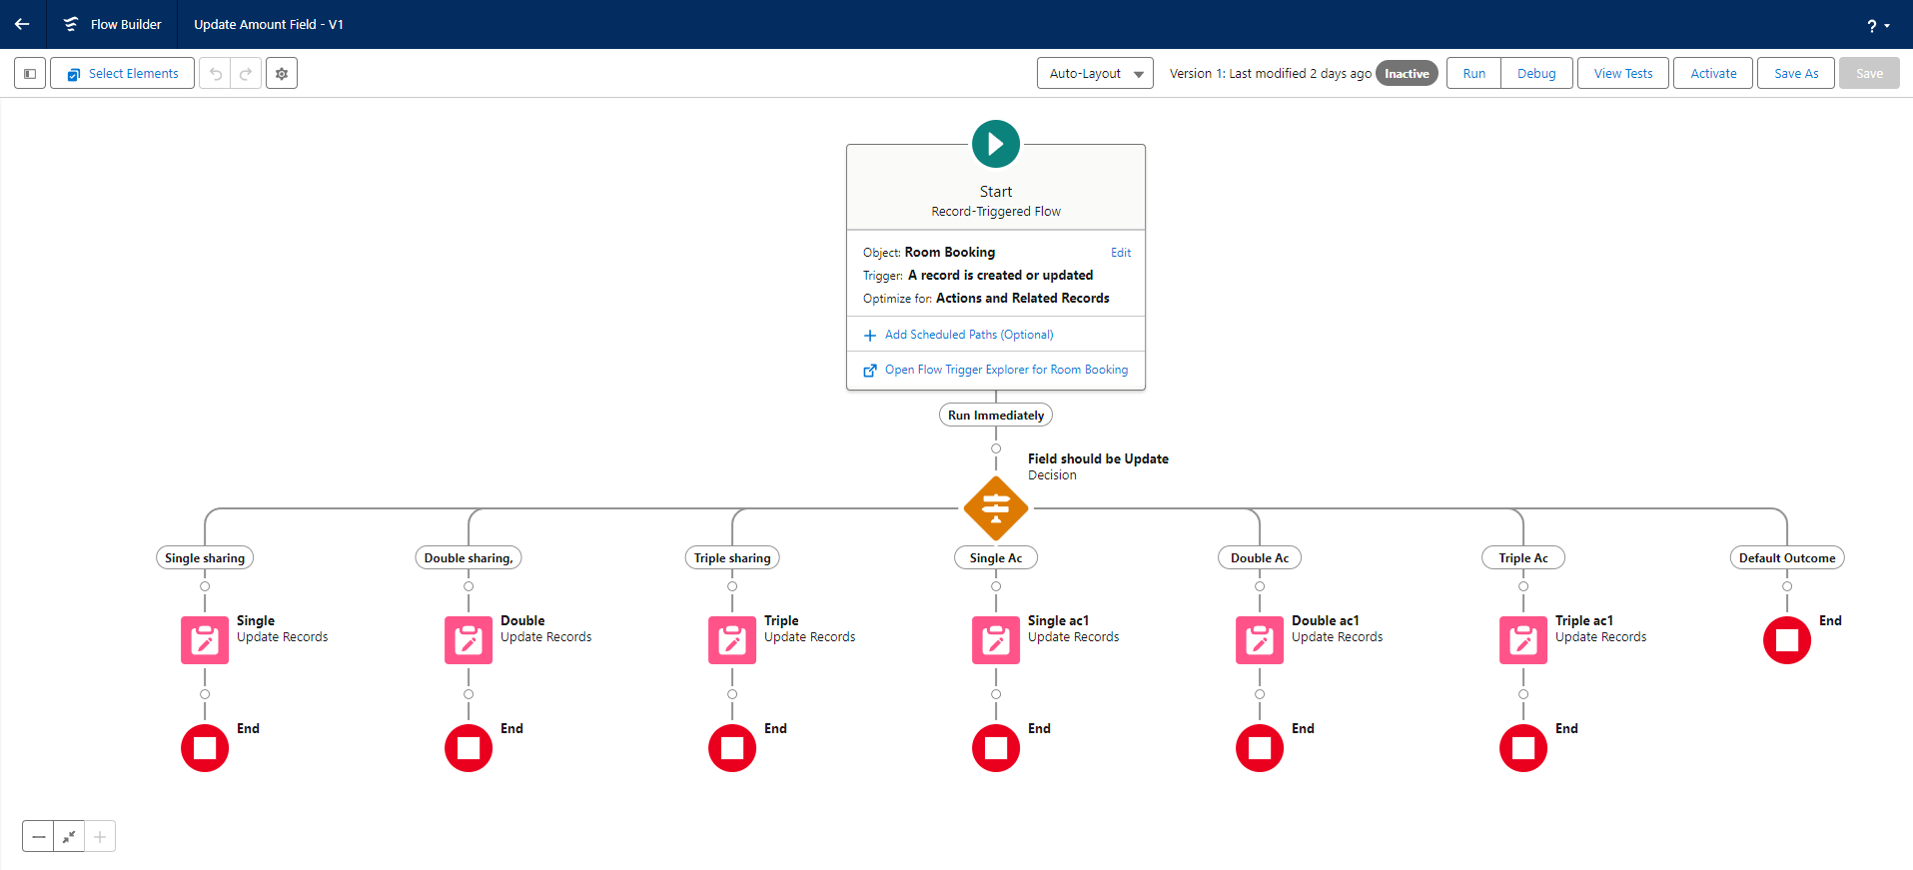

### **Test the Flow**

Go to App Launcher and search for Co-living and select the app

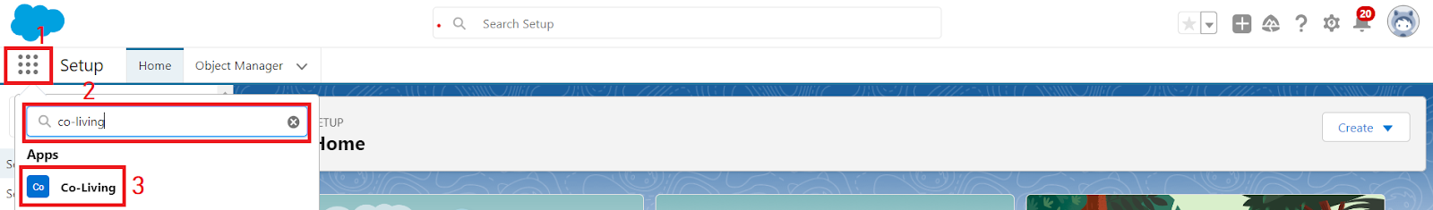

In the Co-living app click on the Room sharing tab and click on new.

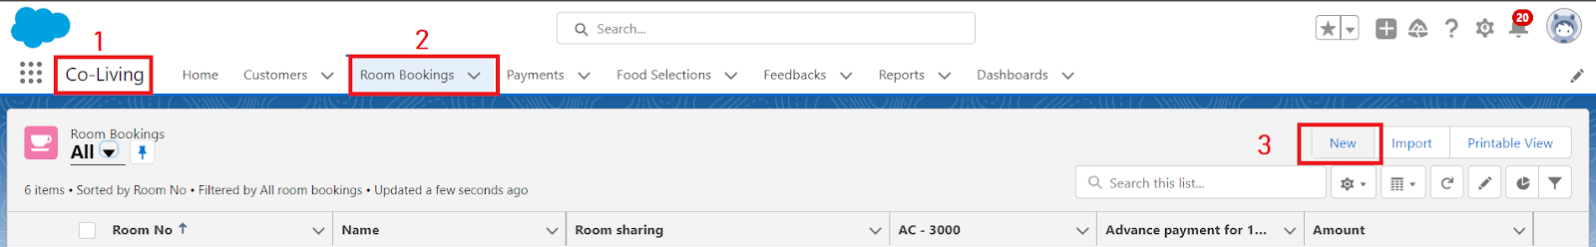

Enter the details like Name, Room sharing, Ac-3000, Advance payment for 1 Month. And the Amount field is empty before saving the record.

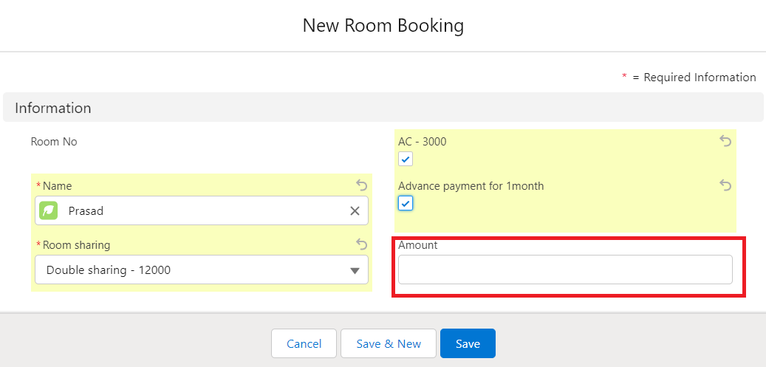

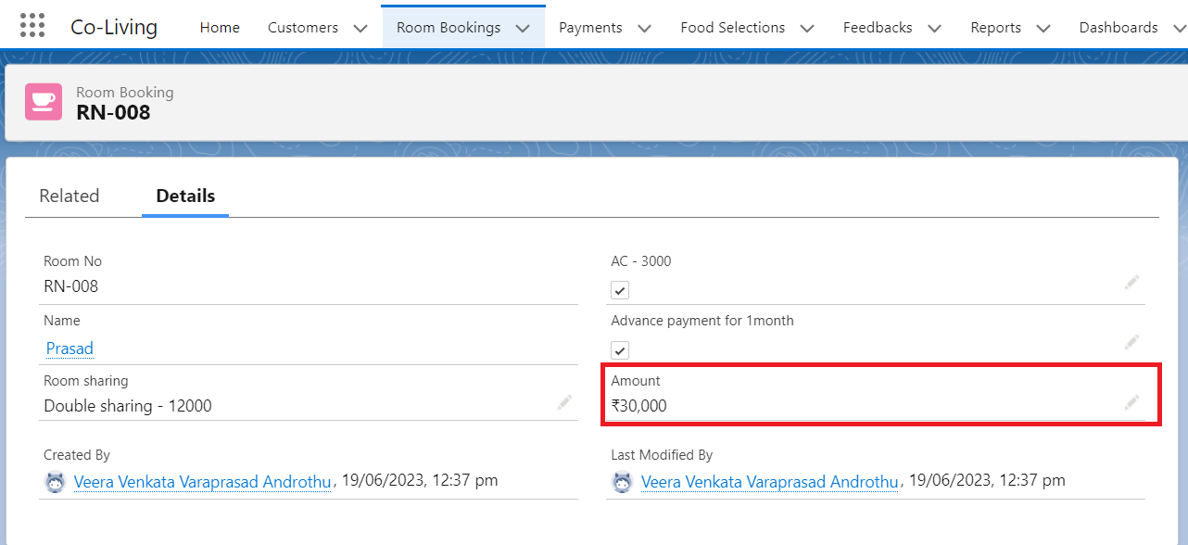

**Screenshot:**

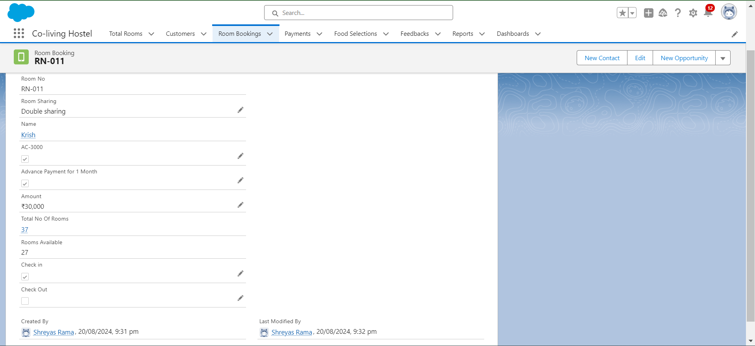

**Thank you**